Angel V. Rivera Galaviz

Professor Alnsour, Yazan

BACS 485

16 December 2020

Miniworld; a slice of the World

Contents

Introduction 2

Problem definition 2

General description: 2

Entities 3

Weak entities 4

ERD 5

Relationships 6

Schema diagram 8

Oracle’s Diagram 9

Mapping ER 10

Populating/views 13

Hadoop/Warehouse 15

Summary 18

Appendices: 19

Appendices- Insert-views 35

Appendixes Hadoop/Warehouse 52

References 67

# Introduction

According to the book Fundamentals of database systems, “A database represents some aspect of the real world, sometimes called the miniworld or the universe of discourse. Changes to the miniworld are reflected in the database (Elmasri and Shamkant).” Ram and Sudha mention that it is important to use some constraints when defining the miniworld since they help to ensure that the structure and content of the miniworld are correctly introduced in the database (Ram and Sudha). There are several constraints mentioned, but most semantics models include entities, attributes, and relationships. An entity is a concept that is used to represent an object or concept of the real world. At the same time entities have attributes such as names, id, addresses, etc. Lastly, entities can form relationships with other entities on the miniworld (Elmasri and Shamkant 2.1.1). In this paper, I will provide a miniworld representation for Zealot Industries Inc. This should help to illustrate the concepts previously mentioned.

# Problem definition

Zealot Industries Inc is a manufacturing firm that employs more than two thousand employees. The problem that Zealot Industries Inc is facing is that the company has been expanding rapidly. Its expansion has surpassed the initial expectations of when it was founded. Because of this, its systems won’t keep up with the increasing expansion of the company (Foster and Godbole).

# General description:

* Zealot Industries Inc is organized into different departments, and each department will have several employees. Each department needs a name, a number that identifies it, and an employee that manages it.
* Each employee works for a department and works for a specific position. Multiple employees can work in the same position. Each employee has a compensation package that includes basic salary and benefits. Each employee is classified based on its salary.
* An employee profile needs employment history, education history, and dependents information.
* The database needs to store the employee's name, SSN, address, salary, gender, and birth date. To keep a level of organization each employee will have a supervisor.
* A project must have at least one employee, and a project can have many employees. Each project is managed by a department. A project must have a name, number, and location.

# Entities

* Entity type DEPARTMENT with attributes DName, Location, DNumber, and MgrSsn. Dnumber will be the Primary key.
* Entity type PROJECT with attributes PName, PNumber, MgrSsn, DNumber. PNumber will be the Primary key.
* Entity type EMPLOYEE with attributes Name, Ssn, Salary, Gender, Address, DNumber, SuperSsn, Birth _date, and Salary_classification. Name will be a composite attribute. It will be composed of First_name, Last_name, and Middle_name. Ssn can be used as Primary key.
* Entity type STUDIED_ON with attributes CName, SSsn, Degree, Start_date, End_date. CName, Degree, and SSsn will form a composite primary key.
* Entity type WORKED_ON with attributes CName, WSsn, Position, Start_date, End_date. CName, Position, and WSsn will form a composite primary key.
* Entity type PACKAGE with attributes PKName, ESsn, Basic_salary, and Benefits. Name and ESsn will form a composite primary key.
* Entity type COLLEGE with attributes CName, and Location. CName will be the primary key.
* Entity type COMPANY with attributes CName, and Location. CName will be the primary key.
* Entity type WORK_ON with attributes ESsn, and PNumber. ESsn and PNumber will form a composite primary key.

# Weak entities

* Weak entity type DEPENDENT with attributes Relationship, Employee, Birth_date, DepName, ESsn. Name can serve as the partial key

# ERD

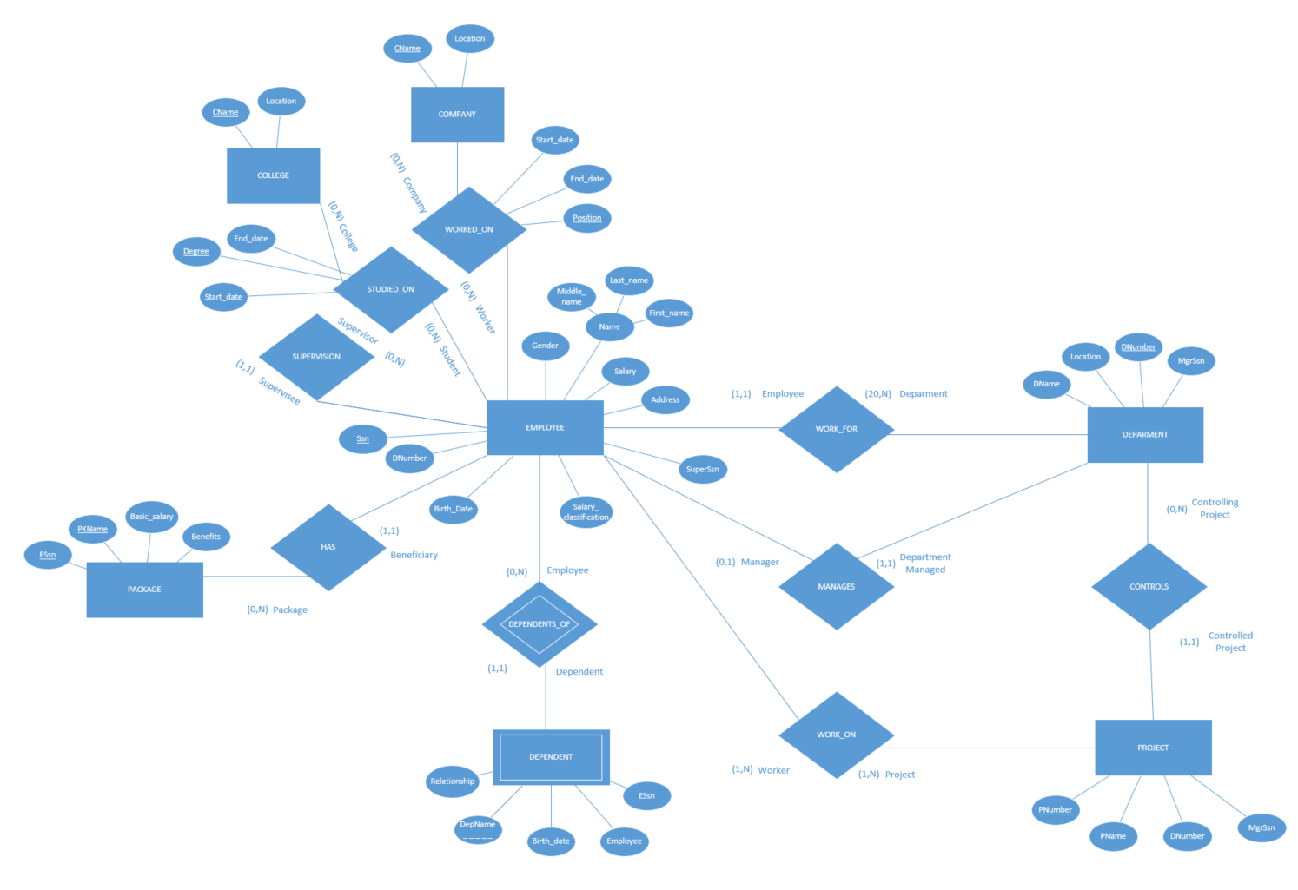

# Relationships

• WORK_FOR is a relationship between the DEPARTMENT and EMPLOYEE. The relationship is 1:N meaning that a department can have many employees, and an employee can work only in one department.

• DEPENDENTS_OF is a relationship between the EMPLOYEE and DEPENDENT. This relationship is the identifying relationship for the weak entity DEPENDENT. The participation of EMPLOYEE is partial because it can exist without a DEPENDENT, and the participation of DEPENDENT is total since it cannot exist without an EMPLOYEE. This relationship is 1:N because an employee can have many dependents, but a dependent can be related to at most one employee.

• WORK_ON is a relationship between PROJECT and EMPLOYEE. The relationship is M:N because multiple employees can work in a project and an employee can be assigned to more than one project.

• CONTROLS is a relationship between DEPARTMENT and PROJECT. This relationship is a 1:N this means that a department can control several projects and a project can belong to only one department.

• MANAGES is a relationship between DEPARTMENT and EMPLOYEE. This relationship is a 1:1 this means that a department can have at most one manager and an employee can manage at most one department.

• HAS is a relationship between PACKAGE and EMPLOYEE. This relationship is a 1:N. This means that a package can have several employees who are assigned to it, and that an employee can have at most one package.

• SUPERVISION is a relationship between EMPLOYEE (working as a supervisor) and EMPLOYEE. This relationship is 1:N meaning that an employee can have at most one supervisor, but a supervisor can supervise several employees.

• STUDIED_ON is a relationship between EMPLOYEE and COLLEGE. This relationship is M:N because an employee may have gone to several colleges and several employees may have gone to the same college.

• WORKED_ON is a relationship between EMPLOYEE and COMPANY. This relationship is M:N because an employee may have worked in several companies and several employees may have worked for the same company.

# Schema diagram

# Oracle’s Diagram

# Mapping ER

I created ten relations on my database, seven to represent ER entities and three to represent M:N relationships. The relations are EMPLOYEE, DEPARTMENT, PROJECT, DEPENDENT, COLLEGE, COMPANY, PACKAGE_ , WORK_ON, WORKED_ON, and STUDIED ON (Appendix A Figure 1.A).

On the relation EMPLOYEE using SQL commands I did add 11 attributes/columns; Ssn, Last_name, Middle_name, First_name, Birth_Date, Salary_classification, Address, Gender, Salary, SuperSsn, and Dnumber (Appendix B Figure 2.B). I used Ssn as the primary key. Then I added two foreign keys using Oracle’s GUI interface. The first foreign key is SuperSsn which references Ssn on the EMPLOYEE relation. This foreign key is used to map the relationship SUPERVISION (1:N). The second one is Dnumber which references Dnumber on the DEPARTMENT relation. This foreign key is used to map the relationship WORK_FOR (1:N) (Appendix B Figure 3.B) .

On the relation DEPARTMENT using SQL commands I added 4 attributes/columns; DName, Location, DNumber, and MgrSsn (Appendix C Figure 4.C). I used Dnumber as the primary key. I also added a foreign key MgrSsn which references Ssn on the EMPLOYEE relation. This foreign key is used to map the relationship MANAGES (1:1). The foreign key was created using Oracle’s GUI interface (Appendix C Figure 5.C).

On the relation PROJECT using SQL commands I did add 4 attributes/columns; PName, PNumber, DNumber, and MgrSsn (Appendix D Figure 6.D). I used Pnumber as the primary key. I also added two foreign keys. The first one is MgrSsn which references MgrSsn on the DEPARMENT relation. The second one is DNumber which references DNumber on the DEPARMENT relation. This foreign key is used to map the relationship CONTROLS (1:N). For some reason, oracle did not let me create the foreign key MgrSsn using Oracle’s GUI interface, so I did create it with a SQL command. The foreign key Dnumber was added using Oracle’s GUI interface (Appendix D Figure 7.D, Figure 8.D). Figure 7.D makes it seem like the foreign key MgrSsn was also added using Oracle’s GUI interface, but it did only show up after I added it with a SQL command.

On the relation DEPENDENT using SQL commands I added five attributes/columns; DepName, ESsn, Relationship, Birth_Date, and Employee (Appendix E Figure 9.E). I used a composite primary key formed with DepName and ESsn. I also added the foreign key Essn which references Ssn on the EMPLOYEE relation. This foreign key is used to map the relationship DEPENDENTS_OF (1:N). The foreign key was created along with the relation using a SQL command (Appendix E Figure 9.E).

On the relation COLLEGE using SQL commands I added two attributes/columns; CName and Location. I did use CName as the primary key (Appendix F Figure 10.F).

On the relation COMPANY using SQL commands I added two attributes/columns; CName and Location. I did use CName as the primary key (Appendix G Figure 11.G).

On the relation STUDIED_ON using SQL commands I added five attributes/columns; CName, Degree, SSsn, Start_date, and End_date (Appendix I Figure 13.I). I did use a composite primary key formed with CName, Degree, and SSsn. I also did add two foreign keys. The first one is SSsn which references Ssn on the EMPLOYEE relation. The second one is CName which references CName on the COLLEGE relation. These two foreign keys are used to map the relationship STUDIED_ON (M:N). The foreign keys were created along with the relation using SQL commands (Appendix I Figure 13.I).

On the relation WORKED_ON using SQL commands I added five attributes/columns; CName, Position, WSsn, Start_date, and End_date (Appendix J Figure 14.J). I used a composite primary key formed with CName, Position, and WSsn. I also added two foreign keys. The first one is WSsn which references Ssn on the EMPLOYEE relation. The second one is CName which references the COMPANY relation. These two foreign keys are used to map the relationship WORKED_ON (M:N). The foreign keys were created along with the relation using SQL commands (Appendix J Figure 14.J).

On the relation WORK_ON using SQL commands I added two attributes/columns; ESsn, and PNumber (Appendix K Figure 15.K). I used a composite primary key formed with ESsn and PNumber. I also added two foreign keys. The first one is ESsn which references Ssn on the EMPLOYEE relation. The second one is PNumber which references PNumber on the PROJECT relation. These two foreign keys are used to map the relationship WORK_ON (M:N). The foreign keys were created along with the relation using SQL commands (Appendix K Figure 15.K).

On the relation PACKAGE_ using SQL commands I added four attributes/columns; PKName, ESsn, Basic_salary, and benefits (Appendix H Figure 12.H). I used a composite primary key formed with PKName and ESsn. I also added the foreign key ESsn which references Ssn on the EMPLOYEE relation. This foreign key is used to map the relationship HAS (1:N). The foreign key was created along with the relation using a SQL command (Appendix H Figure 12.H).

# Populating/views

In total I added seventy-nine new tuples to my database. Ten to the EMPLOYEE relation(A.1 F.16.1), five to the DEPARTMENT relation(A.2 F.17.2), seven to the COLLEGE relation(A.3 F.18.3), eight to the DEPENDENT relation(A.4 F.19.4), ten to the PACKAGE_ relation(A.5 F.20.5), seven to the COMPANY relation(A.6 F.21.6), ten to the PROJECT relation(A.7 F.22.7), five to the STUDIED_ON relation(A.8 F.23.8), seven to the WORKED_ON relation(A.9 F.24.9), and ten to the WORK_ON relation(A.10 F.25.10).

The first view I created was FAMILY. This view gathers information from the relations EMPLOYEE, DEPARTMENT and DEPENDENT. It presents first_name renamed as worker_name, last_name, dname renamed as manages, depname renamed as child_name, and relationship. The view shows the name and last name of each employee that manages a department. In addition, it shows the names of the employee’s dependents and the type of relationship it has with them (Appendix 11 Figure 26.11).

The second view I created was DEPT_INFO. This view gathers information from the relations EMPLOYEE and DEPARTMENT. It presents dname renamed as department, COUNT(*) renamed as number_of_employees, and SUM(Salary) renamed as total_salary. The view shows the name of each department, the number of employees that work on it, and the total sum of the salaries from the employees who work in each department (Appendix 12 Figure 27.12).

The third view I created was PROJECT_INFO. This view gathers information from the relations PROJECT renamed as E, DEPARTMENT renamed as DM, and EMPLOYEE renamed as D. The relations were renamed to avoid ambiguity between attributes. It presents pname renamed as project_name, dname renamed as controlled_by, first_name renamed as managed_by and location renamed as located_at. The view shows the name of each project, the department that manages, who is the manager and where the project is located (Appendix 13 Figure 28.13).

The fourth view I created was EMPLOYEE_EDUCATION. This view gathers information from the relations EMPLOYEE and STUDIED_ON. It presents first_name renamed as employee_name, degree, cname renamed as college, start_date renamed as began, and end_date renamed as finished. This view shows the names of the employees that have gone to college, the degree that they got, the college’s name, and the date in which they started and finished their education at that college (Appendix 14 Figure 29.14).

The fifth view I created was EMPLOYEE_WORKHIS. This view gathers information from the relations EMPLOYEE, and WORKED_ON. It presents first_name renamed as employee_name, position, cname renamed as company, start_date renamed as began, and end_date renamed as finished. This view shows the names of the employees that have previous work experience, it shows the position they had on their previous work, the company’s name, and the date in which they started and finished working on each company (Appendix 15 Figure 30.15).

The sixth view I created was WORK_ON1. This view gathers information from the relations EMPLOYEE renamed as E, PACKAGE_, and DEPARTMENT renamed as EM. The relations EMPLOYEE and DEPARTMENT were renamed to avoid ambiguity between attributes. It presents first_name renamed as employee_name, dname renamed as department_name, location, and pkname renamed as package_name. This view shows the name of each employee, the department they work on, the department’s location, and the name of the benefits package they have (Appendix 16 Figure 31.16).

# Hadoop/Warehouse

I added a total of ten relations to my Oracle’s data warehouse; FactFinal_College(X23.23), FactFinal_Company(Y24.24), FactFinal_Department(Z25.25), FactFinal_Dependent(AA26.26), FactFinal_Employee(AB27.27), FactFinal_Package(AC28.28), FactFinal_Project(AD29.29), FactFinal_Studied_on(AE30.30), FactFinal_Work_on(AF31.31), FactFinal_Worked_on(AG32.32).

I added a total of ten relations to Hadoop; College (A1.1), Company (B2.2), Department (C3.3), Dependent (D4.4), Employee (E5.5), Package (F6.6), Project (G7.7), Studied_on (H8.8), Worked_on (I9.9), and Work_on (J10.10). I also created eleven graphs to help interpret the data I have on my relations. Seven of those graphs are based solely on the Employee relation, while the rest are based on a combination of the employee and package relations. This was possible due to a joint query (R18.18).

The first graph is a bar graph which shows the salary of each employee. This was created by using the salary on the y-axis and the employee’s name on the x-axis (K11.11).

The second graph is a bar graph which shows what department each employee belongs to. This was created by using the department number on the y-axis and the employee’s name of the x-axis (L12.12).

The third graph is a pie graph which shows the different classifications of salaries and the volume of each slide corresponds to the salary of each employee. Each slide has a different color for each employee (M13.13).

The fourth graph is a scatter plot graph which shows the salary of each employee, and the department in which they work. This was created by having the salary on the y-axis, the department number on the x-axis, and each employee is differentiated by a unique color. The size of each dot is proportional to the salary of each employee (N14.14).

The fifth graph is a bar graph that shows the salary of each employee, and separates employees based on gender. This was created by having the salary on the y-axis and the gender on the x-axis. Each employee has a unique color. This graph shows that on average women earn more than men (O15.15).

The sixth graph is a bar graph that shows the salaries per department while separating them by gender. This was created by having the salaries on the y-axis and the gender on the x-axis. This graph shows that men earn more than women in department 4, but that women earn more than men in department 1. It also shows that women earn more on average (P16.16).

The seventh graph is a bar graph that shows the basic salary that corresponds to each benefit package. This was created by having the basic salary on the y-axis and the package name on the x-axis (Q17.17).

The eighth graph is a bar graph that shows the salary of each employee and the basic salary of each employee. This was created by having the salary on the y-axis and the employee’s name on the x-axis. Each employee has a unique color. This graph shows how an employee’s salary compares to its basic salary (minimum set by benefits package) (S19.19).

The ninth graph is a bar graph that shows the salary of each employee while grouping employees based on the benefits package they have. This was created by having the salary on the y-axis and the package’s name on the x-axis. The graph shows that even employees that have a basic benefits package can have higher or equal salaries than employees that have ‘better’ benefits packages (T20.20).

The tenth graph is a bar graph that shows the basic salary of each employee while groping employees by gender. This was created by having salary on the y-axis and gender on the x-axis. Each employee has a unique color. This graph shows that while women have a higher salary average, men have a higher average basic salary (U21.21).

The last graph is a bar graph that shows the salary of each employee while groping employees by the department they work for. This was created by having the salary on the y-axis and the department number on the x-axis. This graph shows that department 2 is the only department that does not have an employee that makes more than $40,000 a year (V22.22).

# Summary

To summarize the miniworld is a part of the real world. When defining the miniworld is important to use some constraints like entities, attributes, and relationships to make sure that the structure of the miniworld is represented correctly in the database (Ram and Sudha). The miniworld could be a school, a hospital, etc. On this occasion, the miniworld was the company Zealot Industries Inc. Zealot Industries Inc requested my help to create a miniworld description of their company hoping that it could help their systems to keep up with the increasing growth of the company. At the end I had to create ten relations on my database, seven to represent ER entities and three to represent M:N relationships. Each of them with their corresponding attributes and relationships. Other relationships such as 1:1 relationships were represented by simply adding foreign keys to the relations.

I believe that, if Zealot Industries Inc follows the miniworld or description, I provided for the company’s systems, there could not be any problems if the company continues growing at the rate it is doing it right now.

Credit is given to Elmasri and Shamkant since I based my structure on their design and used the names, they provided for entities, attributes, and relationships since I considered they were appropriate for the miniworld description of Zealot Industries Inc.

# Appendices:

1. All relations
2. Employee relation
3. Department relation
4. Project relation
5. Dependent relation
6. College relation
7. Company relation
8. Package_ relation
9. Studied_on relation
10. Worked_on relation
11. Work_on relation

Appendix A

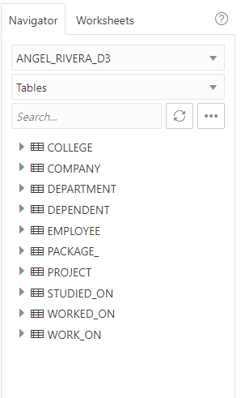

Figure 1.A

Appendix B

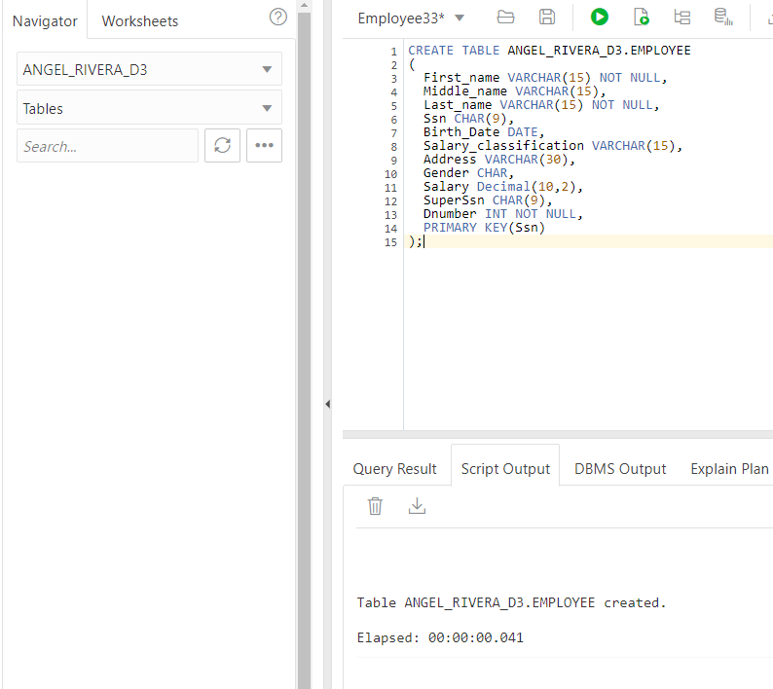

Figure 2.B

CREATE TABLE ANGEL_RIVERA_D3.EMPLOYEE

(

First_name VARCHAR(15) NOT NULL,

Middle_name VARCHAR(15),

Last_name VARCHAR(15) NOT NULL,

Ssn CHAR(9),

Birth_Date DATE,

Salary_classification VARCHAR(15),

Address VARCHAR(30),

Gender CHAR,

Salary Decimal(10,2),

SuperSsn CHAR(9),

Dnumber INT NOT NULL,

PRIMARY KEY(Ssn)

);

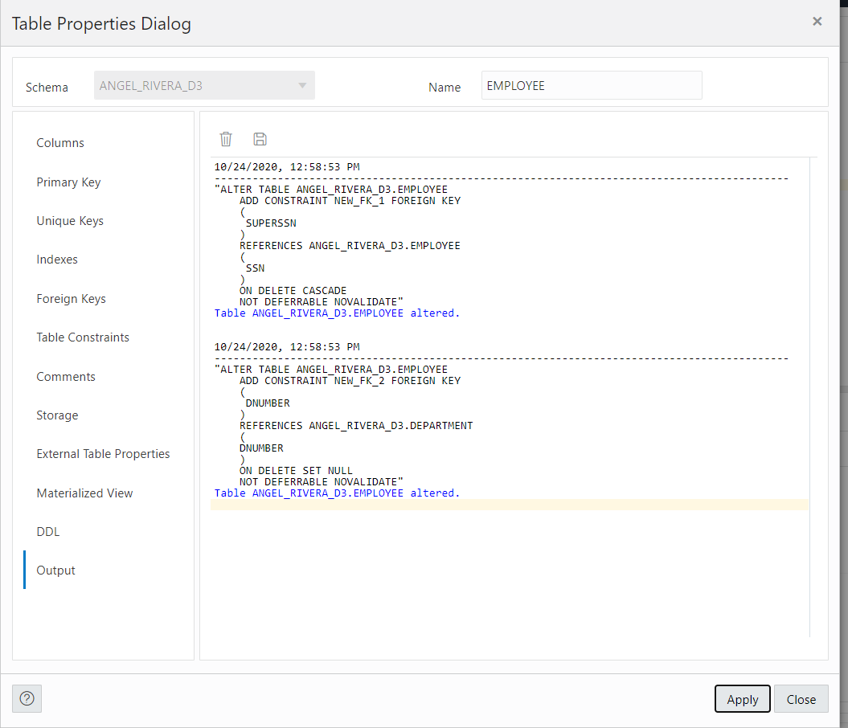

Figure 3.B

Appendix C

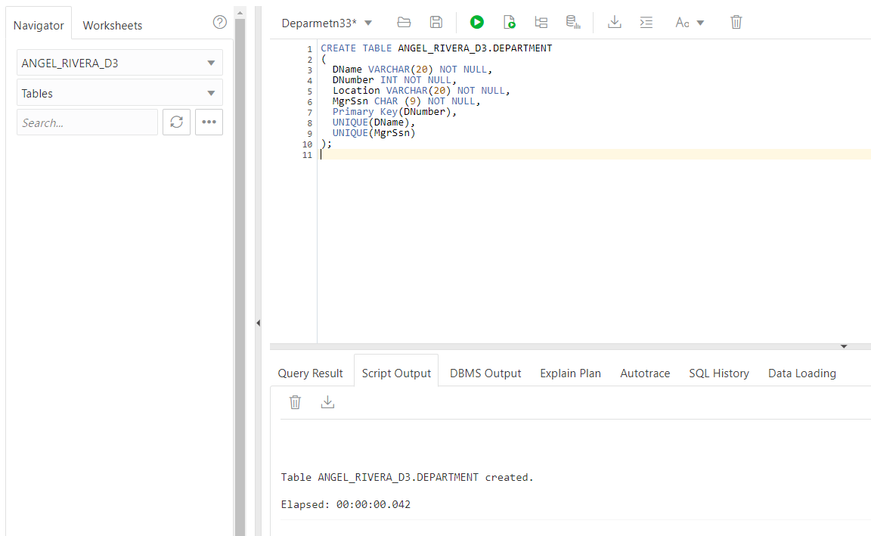

Figure 4.C

CREATE TABLE ANGEL_RIVERA_D3.DEPARTMENT

(

DName VARCHAR(20) NOT NULL,

DNumber INT NOT NULL,

Location VARCHAR(20) NOT NULL,

MgrSsn CHAR (9) NOT NULL,

Primary Key(DNumber),

UNIQUE(DName),

UNIQUE(MgrSsn),

FOREIGN KEY (MgrSsn) REFERENCES ANGEL_RIVERA_D3.EMPLOYEE (Ssn) ON DELETE SET NULL

);

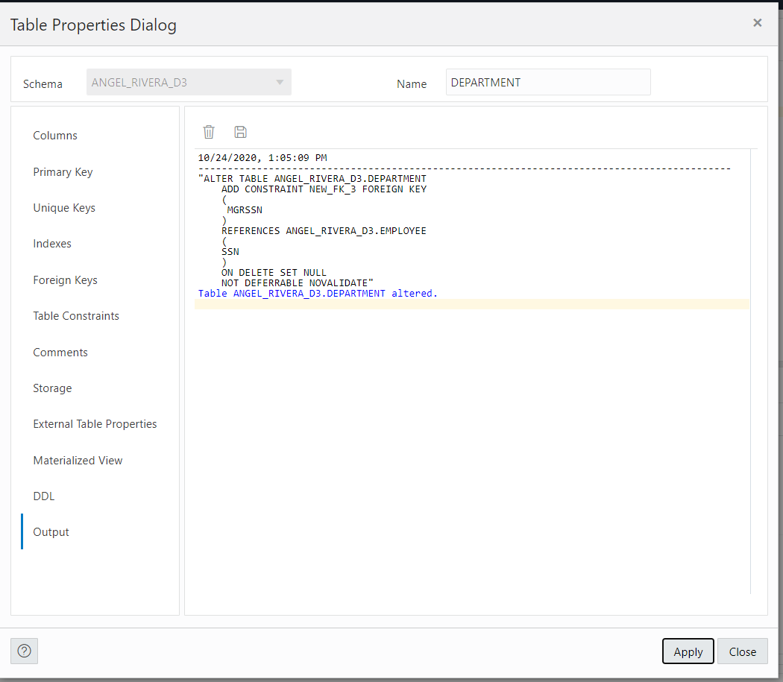

Figure 5.C

Appendix D

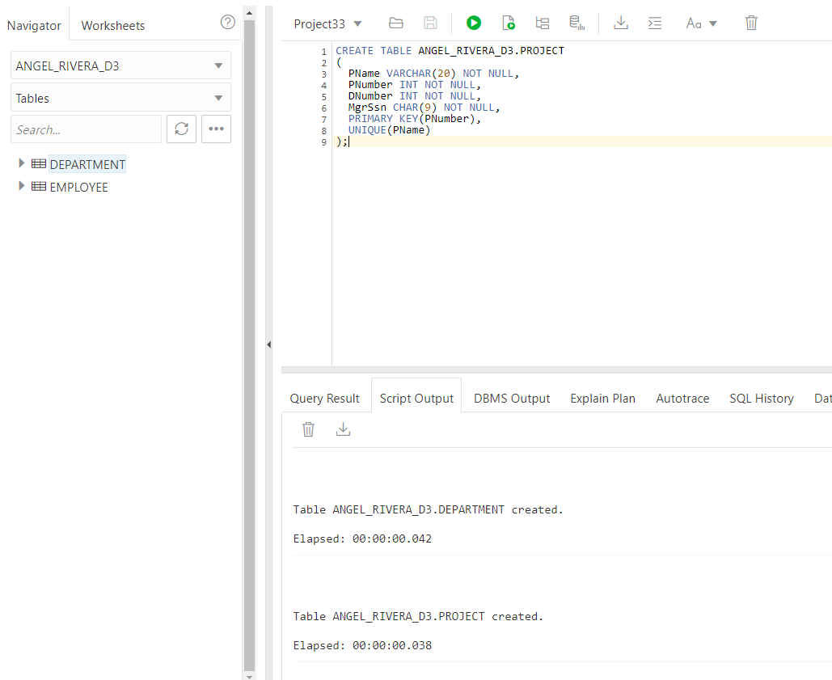

Figure 6.D

CREATE TABLE ANGEL_RIVERA_D3.PROJECT

(

PName VARCHAR(20) NOT NULL,

PNumber INT NOT NULL,

DNumber INT NOT NULL,

MgrSsn CHAR(9) NOT NULL,

PRIMARY KEY(PNumber),

UNIQUE(PName)

);

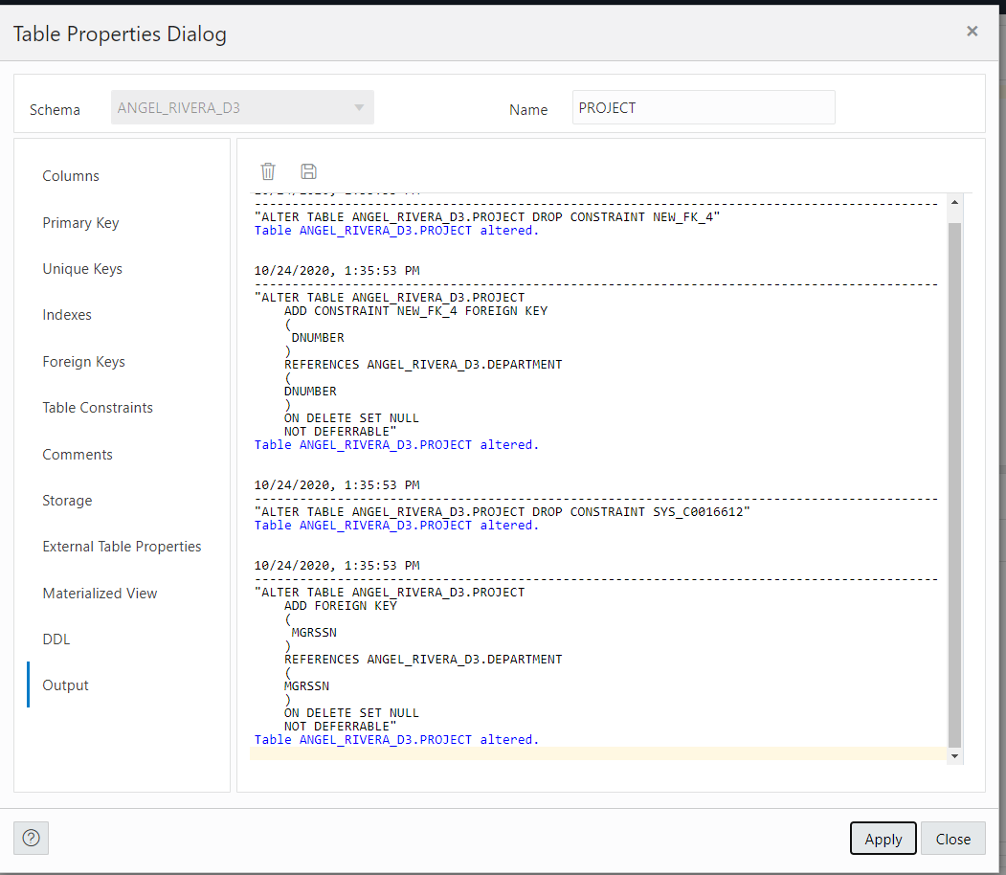

Figure 7.D

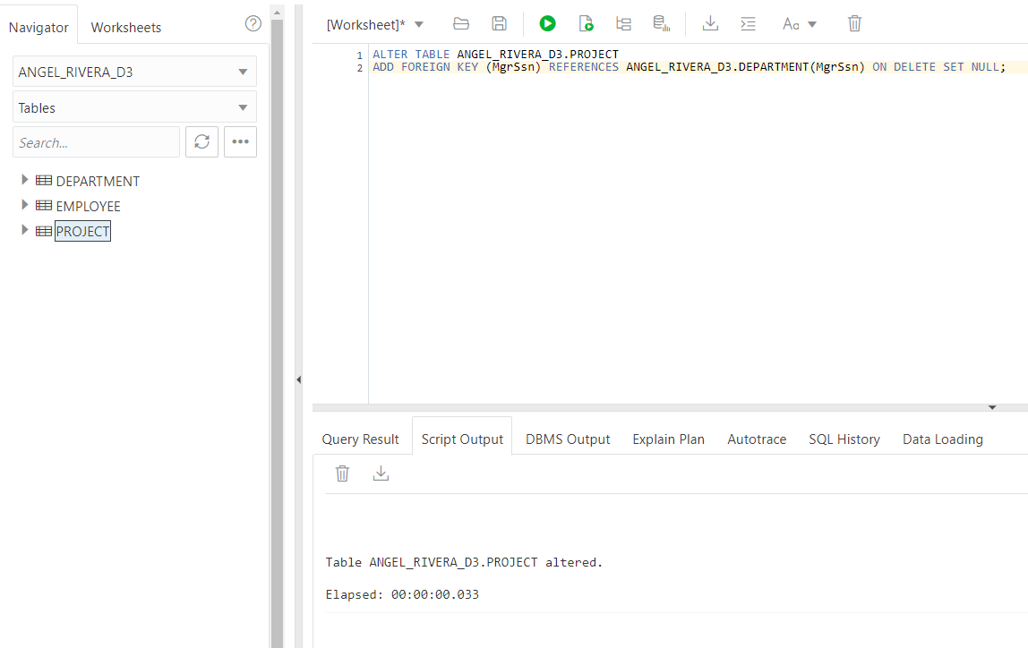

Figure 8.D

ALTER TABLE ANGEL_RIVERA_D3.PROJECT

ADD FOREIGN KEY (MgrSsn) REFERENCES ANGEL_RIVERA_D3.DEPARTMENT(MgrSsn) ON DELETE SET NULL;

Appendix E

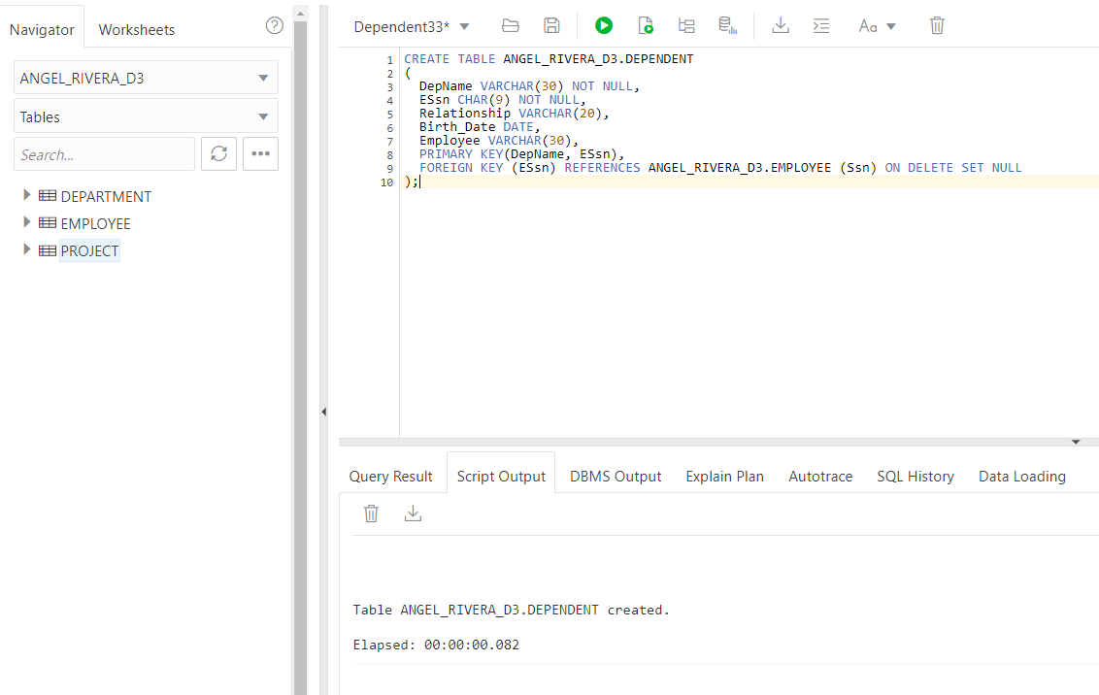

Figure 9.E

CREATE TABLE ANGEL_RIVERA_D3.DEPENDENT

(

DepName VARCHAR(30) NOT NULL,

ESsn CHAR(9) NOT NULL,

Relationship VARCHAR(20),

Birth_Date DATE,

Employee VARCHAR(30),

PRIMARY KEY(DepName, ESsn),

FOREIGN KEY (ESsn) REFERENCES ANGEL_RIVERA_D3.EMPLOYEE (Ssn) ON DELETE SET NULL

);

Appendix F

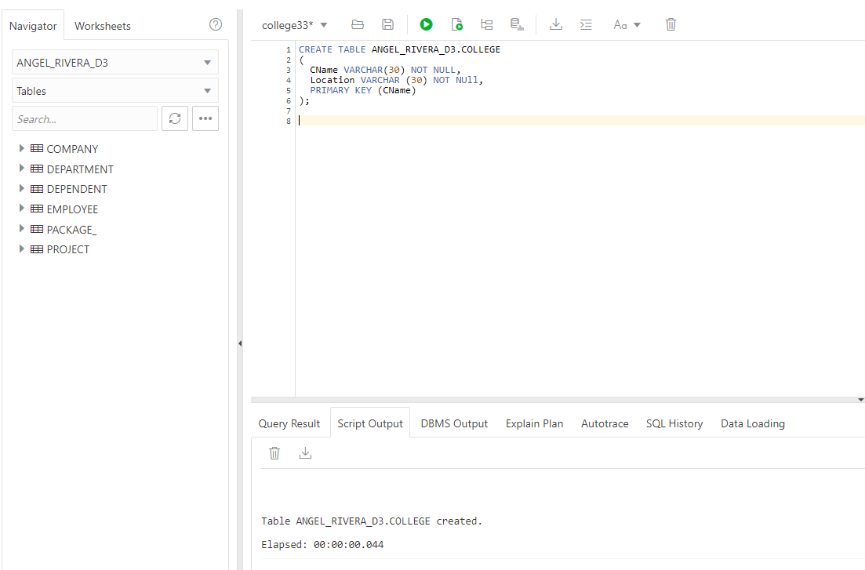

Figure 10.F

CREATE TABLE ANGEL_RIVERA_D3.COLLEGE

(

CName VARCHAR(30) NOT NULL,

Location VARCHAR (30) NOT NULL,

PRIMARY KEY (CName)

);

Appendix G

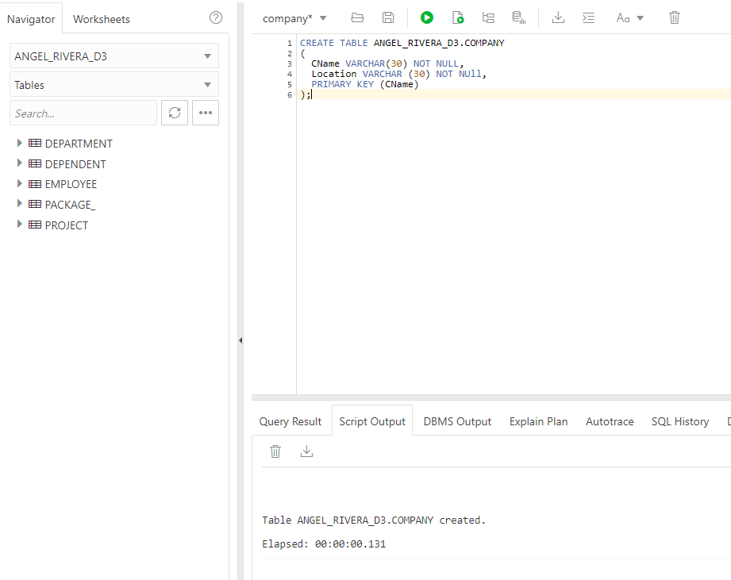

Figure 11.G

CREATE TABLE ANGEL_RIVERA_D3.COMPANY

(

CName VARCHAR(30) NOT NULL,

Location VARCHAR (30) NOT NULL,

PRIMARY KEY (CName)

);

Appendix H

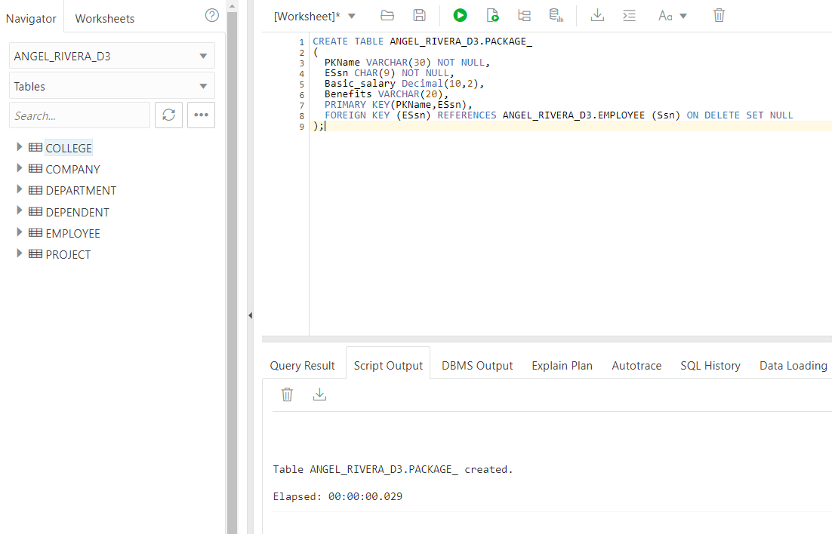

Figure 12.H

CREATE TABLE ANGEL_RIVERA_D3.PACKAGE_

(

PKName VARCHAR(30) NOT NULL,

ESsn CHAR(9) NOT NULL,

Basic_salary Decimal(10,2),

Benefits VARCHAR(20),

PRIMARY KEY(PKName, ESsn),

FOREIGN KEY (ESsn) REFERENCES ANGEL_RIVERA_D3.EMPLOYEE (Ssn) ON DELETE SET NULL

);

Appendix I

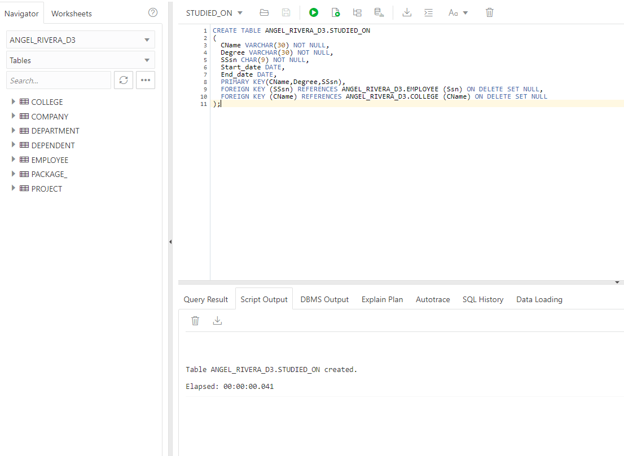

Figure 13.I

CREATE TABLE ANGEL_RIVERA_D3.STUDIED_ON

(

CName VARCHAR(30) NOT NULL,

Degree VARCHAR(30) NOT NULL,

SSsn CHAR(9) NOT NULL,

Start_date DATE,

End_date DATE,

PRIMARY KEY(CName, Degree, SSsn),

FOREIGN KEY (SSsn) REFERENCES ANGEL_RIVERA_D3.EMPLOYEE (Ssn) ON DELETE SET NULL,

FOREIGN KEY (CName) REFERENCES ANGEL_RIVERA_D3.COLLEGE (CName) ON DELETE SET NULL

);

Appendix J

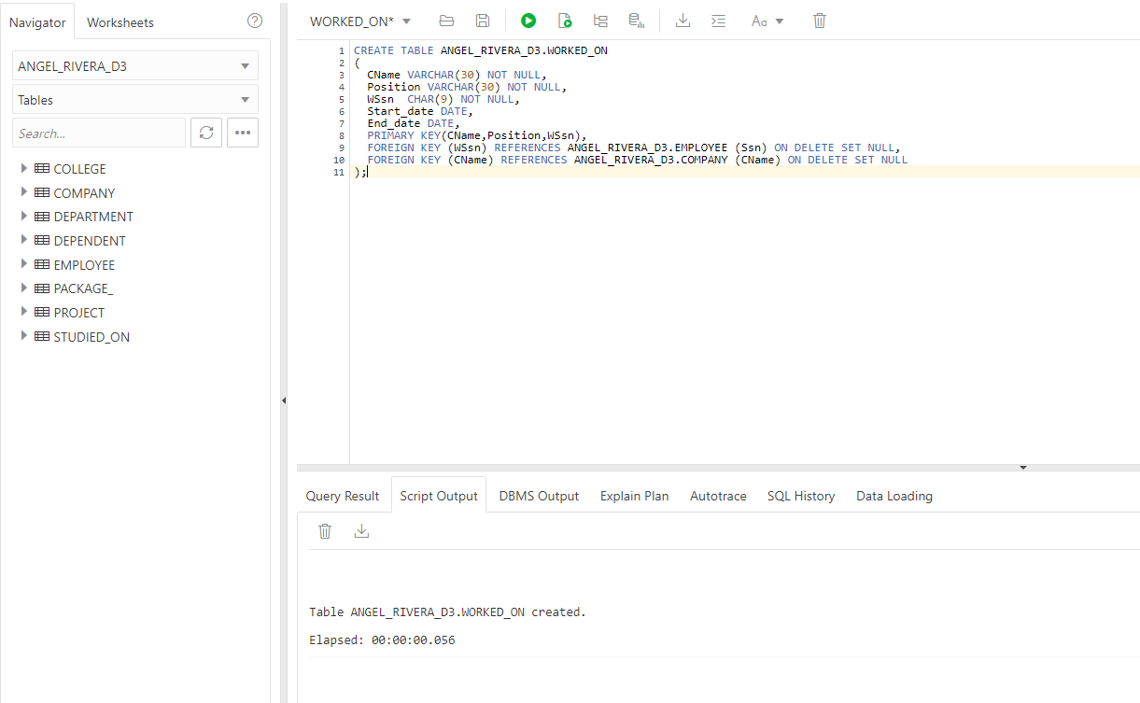

Figure 14.J

CREATE TABLE ANGEL_RIVERA_D3.WORKED_ON

(

CName VARCHAR(30) NOT NULL,

Position VARCHAR(30) NOT NULL,

WSsn CHAR(9) NOT NULL,

Start_date DATE,

End_date DATE,

PRIMARY KEY(CName , Position, WSsn),

FOREIGN KEY (WSsn) REFERENCES ANGEL_RIVERA_D3.EMPLOYEE (Ssn) ON DELETE SET NULL,

FOREIGN KEY (CName) REFERENCES ANGEL_RIVERA_D3.COMPANY (CName) ON DELETE SET NULL

);

Appendix K

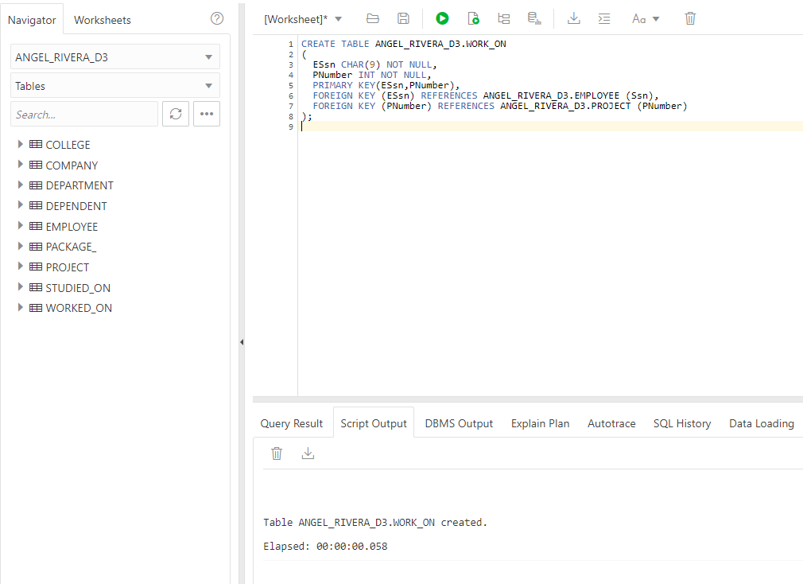

Figure 15.K

CREATE TABLE ANGEL_RIVERA_D3.WORK_ON

(

ESsn CHAR(9) NOT NULL,

PNumber INT NOT NULL,

PRIMARY KEY(ESsn, PNumber),

FOREIGN KEY (ESsn) REFERENCES ANGEL_RIVERA_D3.EMPLOYEE (Ssn),

FOREIGN KEY (PNumber) REFERENCES ANGEL_RIVERA_D3.PROJECT (PNumber)

);

# Appendices- Insert-views

1. Populate EMPLOYEE relation
2. Populate DEPARTMENT relation
3. Populate COLLEGE relation
4. Populate DEPENDENT relation
5. Populate PACKAGE_ relation
6. Populate COMPANY relation
7. Populate PROJECT relation
8. Populate STUDIED_ON relation
9. Populate WORKED_ON relation
10. Populate WORK_ON relation
11. FAMILY view
12. DEPT_INFO view
13. PROJECT_INFO view
14. EMPLOYEE_EDUCATION view
15. EMPLOYEE_WORKHIS view
16. WORK_ON1 view

Appendix 1

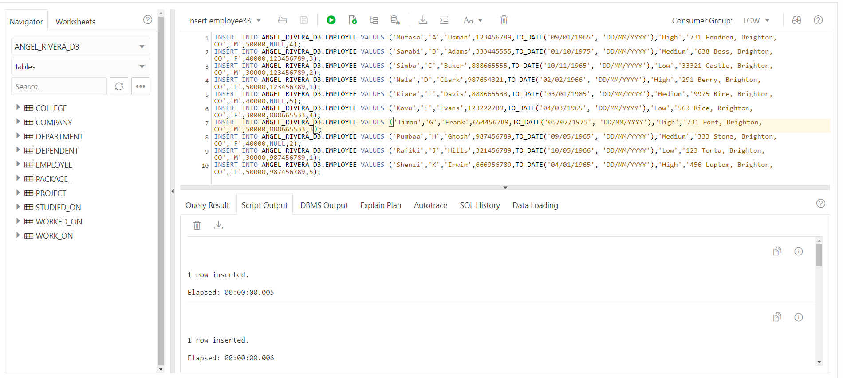

Figure 16.1

INSERT INTO ANGEL_RIVERA_D3.EMPLOYEE VALUES ('Mufasa','A','Usman',123456789,TO_DATE('09/01/1965', 'DD/MM/YYYY'),'High','731 Fondren, Brighton, CO','M',50000,NULL,4);

INSERT INTO ANGEL_RIVERA_D3.EMPLOYEE VALUES ('Sarabi','B','Adams',333445555,TO_DATE('01/10/1975', 'DD/MM/YYYY'),'Medium','638 Boss, Brighton, CO','F',40000,123456789,3);

INSERT INTO ANGEL_RIVERA_D3.EMPLOYEE VALUES ('Simba','C','Baker',888665555,TO_DATE('10/11/1965', 'DD/MM/YYYY'),'Low','33321 Castle, Brighton, CO','M',30000,123456789,2);

INSERT INTO ANGEL_RIVERA_D3.EMPLOYEE VALUES ('Nala','D','Clark',987654321,TO_DATE('02/02/1966', 'DD/MM/YYYY'),'High','291 Berry, Brighton, CO','F',50000,123456789,1);

INSERT INTO ANGEL_RIVERA_D3.EMPLOYEE VALUES ('Kiara','F','Davis',888665533,TO_DATE('03/01/1985', 'DD/MM/YYYY'),'Medium','9975 Rire, Brighton, CO','M',40000,NULL,5);

INSERT INTO ANGEL_RIVERA_D3.EMPLOYEE VALUES ('Kovu','E','Evans',123222789,TO_DATE('04/03/1965', 'DD/MM/YYYY'),'Low','563 Rice, Brighton, CO','F',30000,888665533,4);

INSERT INTO ANGEL_RIVERA_D3.EMPLOYEE VALUES ('Timon','G','Frank',654456789,TO_DATE('05/07/1975', 'DD/MM/YYYY'),'High','731 Fort, Brighton, CO','M',50000,888665533,3);

INSERT INTO ANGEL_RIVERA_D3.EMPLOYEE VALUES ('Pumbaa','H','Ghosh',987456789,TO_DATE('09/05/1965', 'DD/MM/YYYY'),'Medium','333 Stone, Brighton, CO','F',40000,NULL,2);

INSERT INTO ANGEL_RIVERA_D3.EMPLOYEE VALUES ('Rafiki','J','Hills',321456789,TO_DATE('10/05/1966', 'DD/MM/YYYY'),'Low','123 Torta, Brighton, CO','M',30000,987456789,1);

INSERT INTO ANGEL_RIVERA_D3.EMPLOYEE VALUES ('Shenzi','K','Irwin',666956789,TO_DATE('04/01/1965', 'DD/MM/YYYY'),'High','456 Luptom, Brighton, CO','F',50000,987456789,5);

Appendix 2

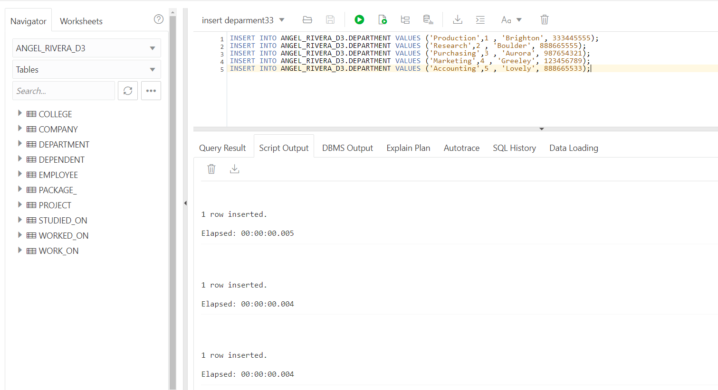

Figure 17.2

INSERT INTO ANGEL_RIVERA_D3.DEPARTMENT VALUES ('Production',1 , 'Brighton', 333445555);

INSERT INTO ANGEL_RIVERA_D3.DEPARTMENT VALUES ('Research',2 , 'Boulder', 888665555);

INSERT INTO ANGEL_RIVERA_D3.DEPARTMENT VALUES ('Purchasing',3 , 'Aurora', 987654321);

INSERT INTO ANGEL_RIVERA_D3.DEPARTMENT VALUES ('Marketing',4 , 'Greeley', 123456789);

INSERT INTO ANGEL_RIVERA_D3.DEPARTMENT VALUES ('Accounting',5 , 'Lovely', 888665533);

Appendix 3

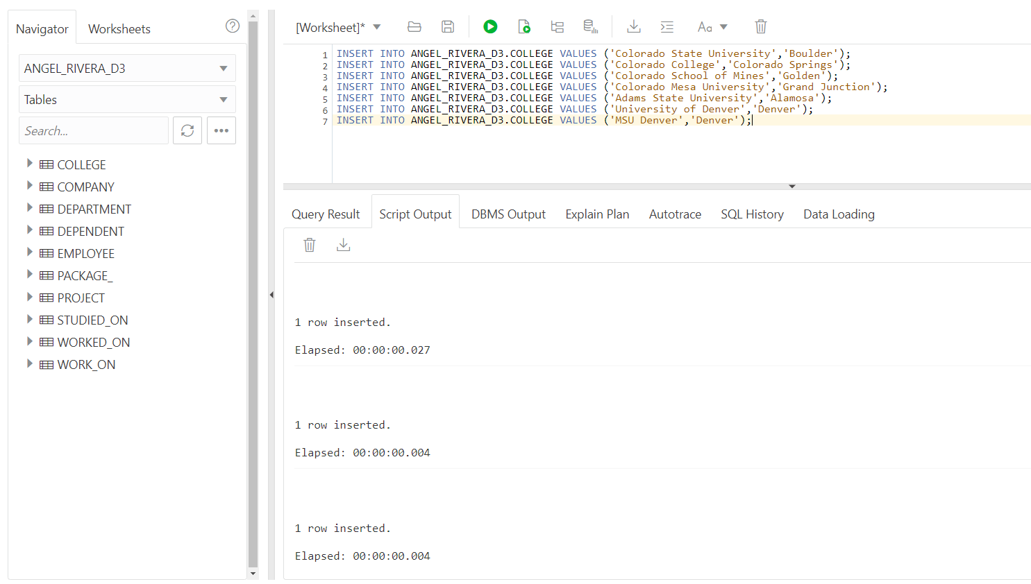

Figure 18.3

INSERT INTO ANGEL_RIVERA_D3.COLLEGE VALUES ('Colorado State University','Boulder');

INSERT INTO ANGEL_RIVERA_D3.COLLEGE VALUES ('Colorado College','Colorado Springs');

INSERT INTO ANGEL_RIVERA_D3.COLLEGE VALUES ('Colorado School of Mines','Golden');

INSERT INTO ANGEL_RIVERA_D3.COLLEGE VALUES ('Colorado Mesa University','Grand Junction');

INSERT INTO ANGEL_RIVERA_D3.COLLEGE VALUES ('Adams State University','Alamosa');

INSERT INTO ANGEL_RIVERA_D3.COLLEGE VALUES ('University of Denver','Denver');

INSERT INTO ANGEL_RIVERA_D3.COLLEGE VALUES ('MSU Denver','Denver');

Appendix 4

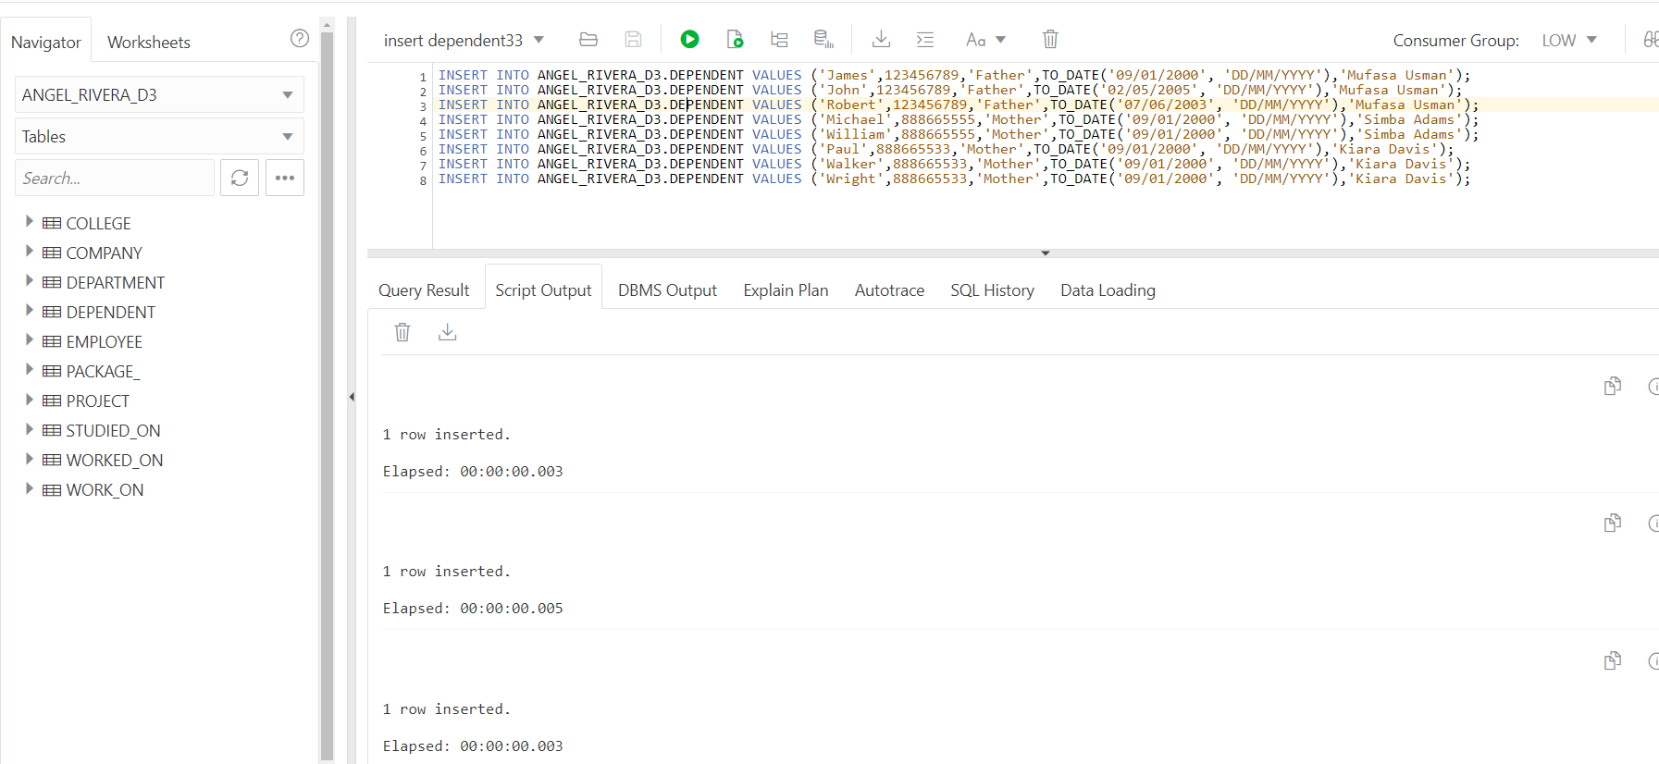

Figure 19.4

INSERT INTO ANGEL_RIVERA_D3.DEPENDENT VALUES ('James',123456789,'Father',TO_DATE('09/01/2000', 'DD/MM/YYYY'),'Mufasa Usman');

INSERT INTO ANGEL_RIVERA_D3.DEPENDENT VALUES ('John',123456789,'Father',TO_DATE('02/05/2005', 'DD/MM/YYYY'),'Mufasa Usman');

INSERT INTO ANGEL_RIVERA_D3.DEPENDENT VALUES ('Robert',123456789,'Father',TO_DATE('07/06/2003', 'DD/MM/YYYY'),'Mufasa Usman');

INSERT INTO ANGEL_RIVERA_D3.DEPENDENT VALUES ('Michael',888665555,'Mother',TO_DATE('09/01/2000', 'DD/MM/YYYY'),'Simba Adams');

INSERT INTO ANGEL_RIVERA_D3.DEPENDENT VALUES ('William',888665555,'Mother',TO_DATE('09/01/2000', 'DD/MM/YYYY'),'Simba Adams');

INSERT INTO ANGEL_RIVERA_D3.DEPENDENT VALUES ('Paul',888665533,'Mother',TO_DATE('09/01/2000', 'DD/MM/YYYY'),'Kiara Davis');

INSERT INTO ANGEL_RIVERA_D3.DEPENDENT VALUES ('Walker',888665533,'Mother',TO_DATE('09/01/2000', 'DD/MM/YYYY'),'Kiara Davis');

INSERT INTO ANGEL_RIVERA_D3.DEPENDENT VALUES ('Wright',888665533,'Mother',TO_DATE('09/01/2000', 'DD/MM/YYYY'),'Kiara Davis');

Appendix 5

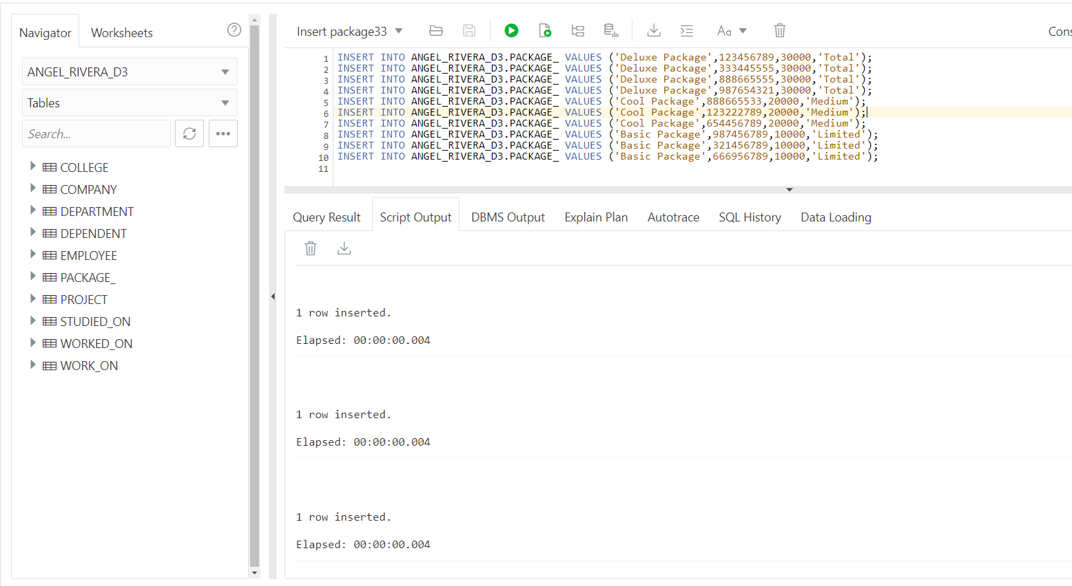

Figure 20.5

INSERT INTO ANGEL_RIVERA_D3.PACKAGE_ VALUES ('Deluxe Package',123456789,30000,'Total');

INSERT INTO ANGEL_RIVERA_D3.PACKAGE_ VALUES ('Deluxe Package',333445555,30000,'Total');

INSERT INTO ANGEL_RIVERA_D3.PACKAGE_ VALUES ('Deluxe Package',888665555,30000,'Total');

INSERT INTO ANGEL_RIVERA_D3.PACKAGE_ VALUES ('Deluxe Package',987654321,30000,'Total');

INSERT INTO ANGEL_RIVERA_D3.PACKAGE_ VALUES ('Cool Package',888665533,20000,'Medium');

INSERT INTO ANGEL_RIVERA_D3.PACKAGE_ VALUES ('Cool Package',123222789,20000,'Medium');

INSERT INTO ANGEL_RIVERA_D3.PACKAGE_ VALUES ('Cool Package',654456789,20000,'Medium');

INSERT INTO ANGEL_RIVERA_D3.PACKAGE_ VALUES ('Basic Package',987456789,10000,'Limited');

INSERT INTO ANGEL_RIVERA_D3.PACKAGE_ VALUES ('Basic Package',321456789,10000,'Limited');

INSERT INTO ANGEL_RIVERA_D3.PACKAGE_ VALUES ('Basic Package',666956789,10000,'Limited');

Appendix 6

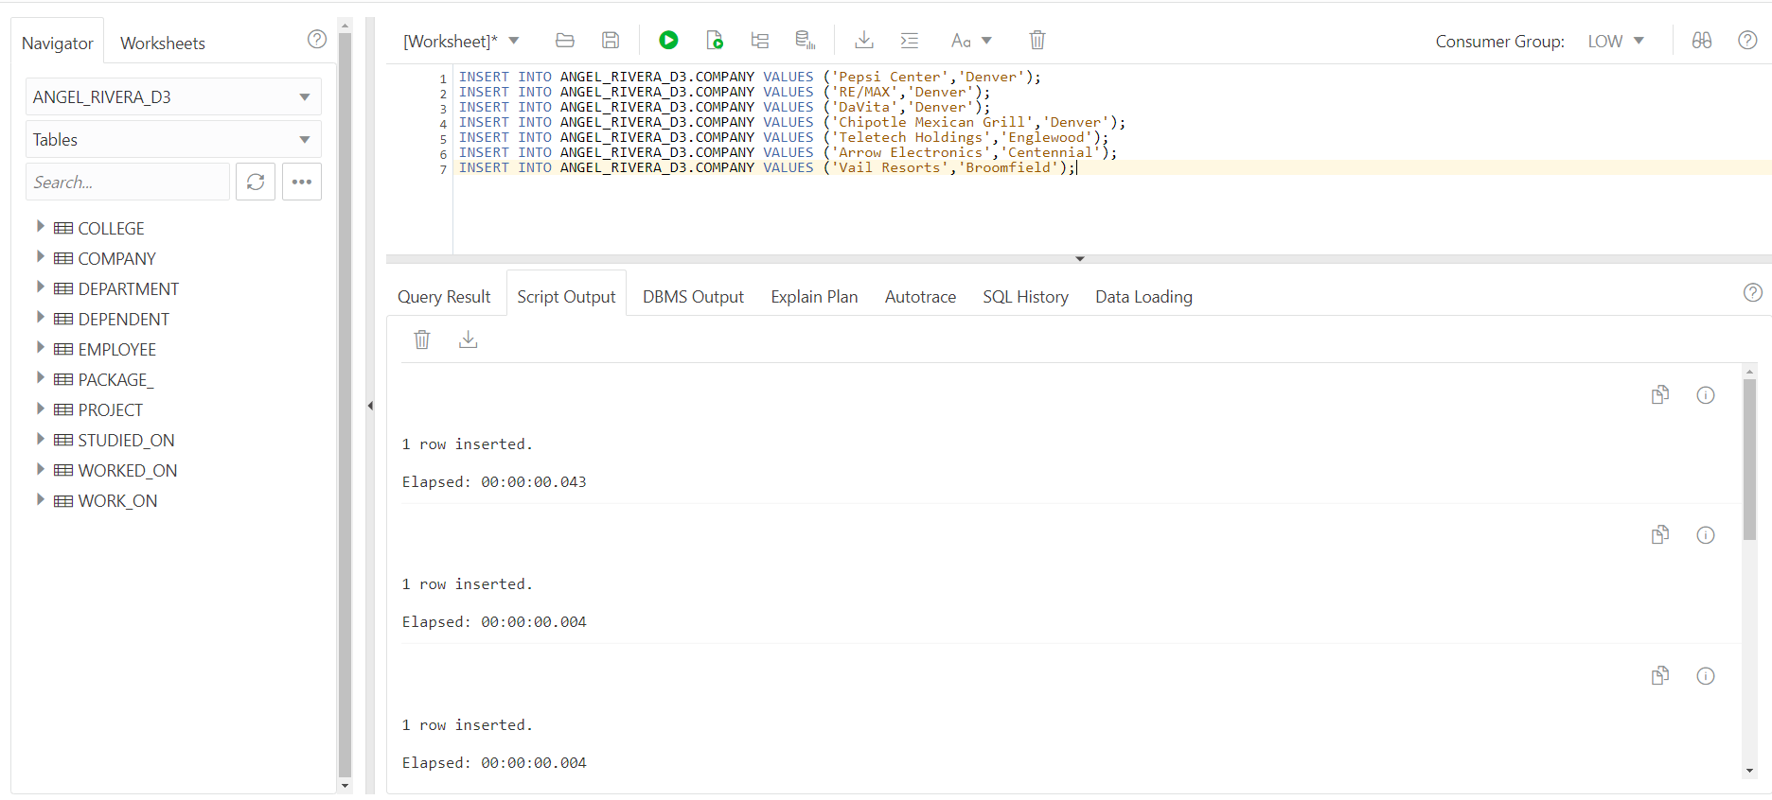

Figure 21.6

INSERT INTO ANGEL_RIVERA_D3.COMPANY VALUES ('Pepsi Center','Denver');

INSERT INTO ANGEL_RIVERA_D3.COMPANY VALUES ('RE/MAX','Denver');

INSERT INTO ANGEL_RIVERA_D3.COMPANY VALUES ('DaVita','Denver');

INSERT INTO ANGEL_RIVERA_D3.COMPANY VALUES ('Chipotle Mexican Grill','Denver');

INSERT INTO ANGEL_RIVERA_D3.COMPANY VALUES ('Teletech Holdings','Englewood');

INSERT INTO ANGEL_RIVERA_D3.COMPANY VALUES ('Arrow Electronics','Centennial');

INSERT INTO ANGEL_RIVERA_D3.COMPANY VALUES ('Vail Resorts','Broomfield');

Appendix 7

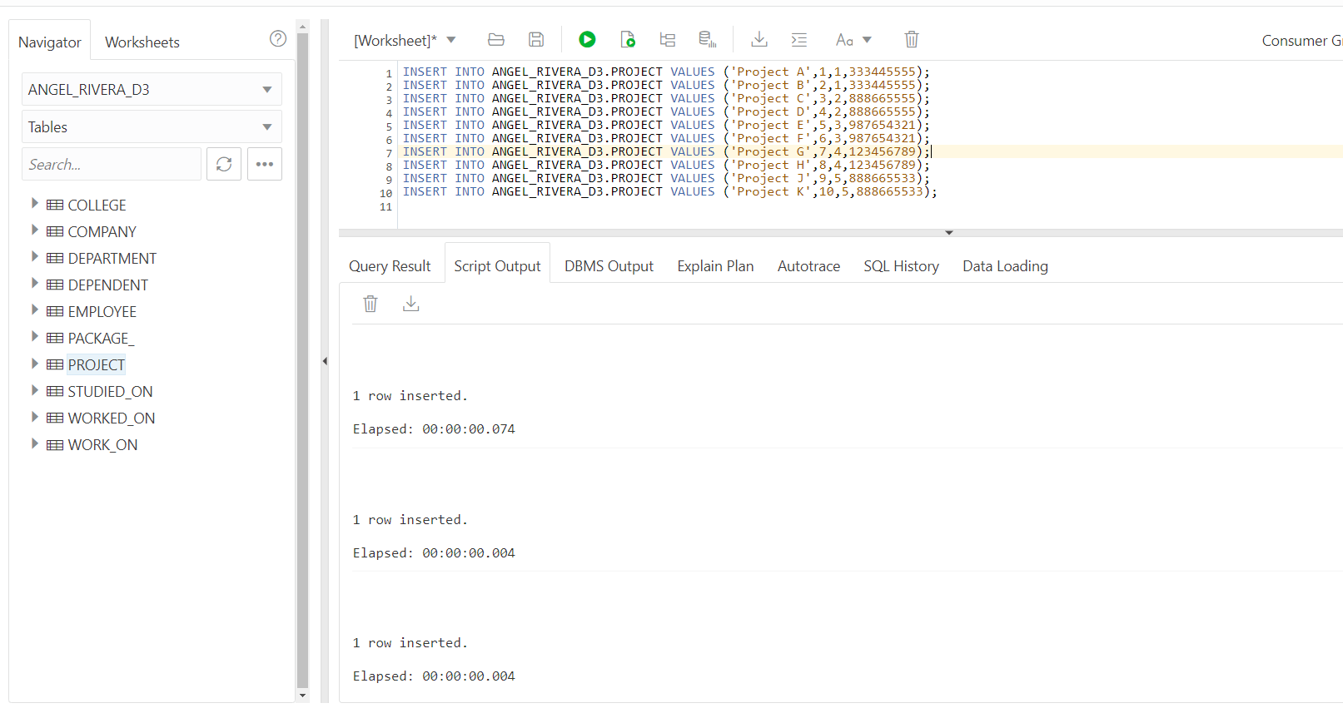

Figure 22.7

INSERT INTO ANGEL_RIVERA_D3.PROJECT VALUES ('Project A',1,1,333445555);

INSERT INTO ANGEL_RIVERA_D3.PROJECT VALUES ('Project B',2,1,333445555);

INSERT INTO ANGEL_RIVERA_D3.PROJECT VALUES ('Project C',3,2,888665555);

INSERT INTO ANGEL_RIVERA_D3.PROJECT VALUES ('Project D',4,2,888665555);

INSERT INTO ANGEL_RIVERA_D3.PROJECT VALUES ('Project E',5,3,987654321);

INSERT INTO ANGEL_RIVERA_D3.PROJECT VALUES ('Project F',6,3,987654321);

INSERT INTO ANGEL_RIVERA_D3.PROJECT VALUES ('Project G',7,4,123456789);

INSERT INTO ANGEL_RIVERA_D3.PROJECT VALUES ('Project H',8,4,123456789);

INSERT INTO ANGEL_RIVERA_D3.PROJECT VALUES ('Project J',9,5,888665533);

INSERT INTO ANGEL_RIVERA_D3.PROJECT VALUES ('Project K',10,5,888665533);

Appendix 8

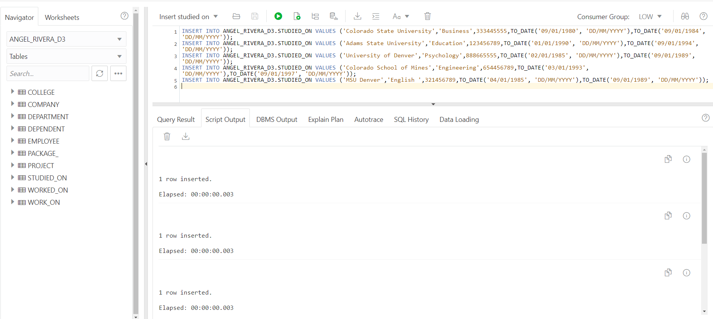

Figure 23.8

INSERT INTO ANGEL_RIVERA_D3.STUDIED_ON VALUES ('Colorado State University','Business',333445555,TO_DATE('09/01/1980', 'DD/MM/YYYY'),TO_DATE('09/01/1984', 'DD/MM/YYYY'));

INSERT INTO ANGEL_RIVERA_D3.STUDIED_ON VALUES ('Adams State University','Education',123456789,TO_DATE('01/01/1990', 'DD/MM/YYYY'),TO_DATE('09/01/1994', 'DD/MM/YYYY'));

INSERT INTO ANGEL_RIVERA_D3.STUDIED_ON VALUES ('University of Denver','Psychology',888665555,TO_DATE('02/01/1985', 'DD/MM/YYYY'),TO_DATE('09/01/1989', 'DD/MM/YYYY'));

INSERT INTO ANGEL_RIVERA_D3.STUDIED_ON VALUES ('Colorado School of Mines','Engineering',654456789,TO_DATE('03/01/1993', 'DD/MM/YYYY'),TO_DATE('09/01/1997', 'DD/MM/YYYY'));

INSERT INTO ANGEL_RIVERA_D3.STUDIED_ON VALUES ('MSU Denver','English ',321456789,TO_DATE('04/01/1985', 'DD/MM/YYYY'),TO_DATE('09/01/1989', 'DD/MM/YYYY'));

Appendix 9

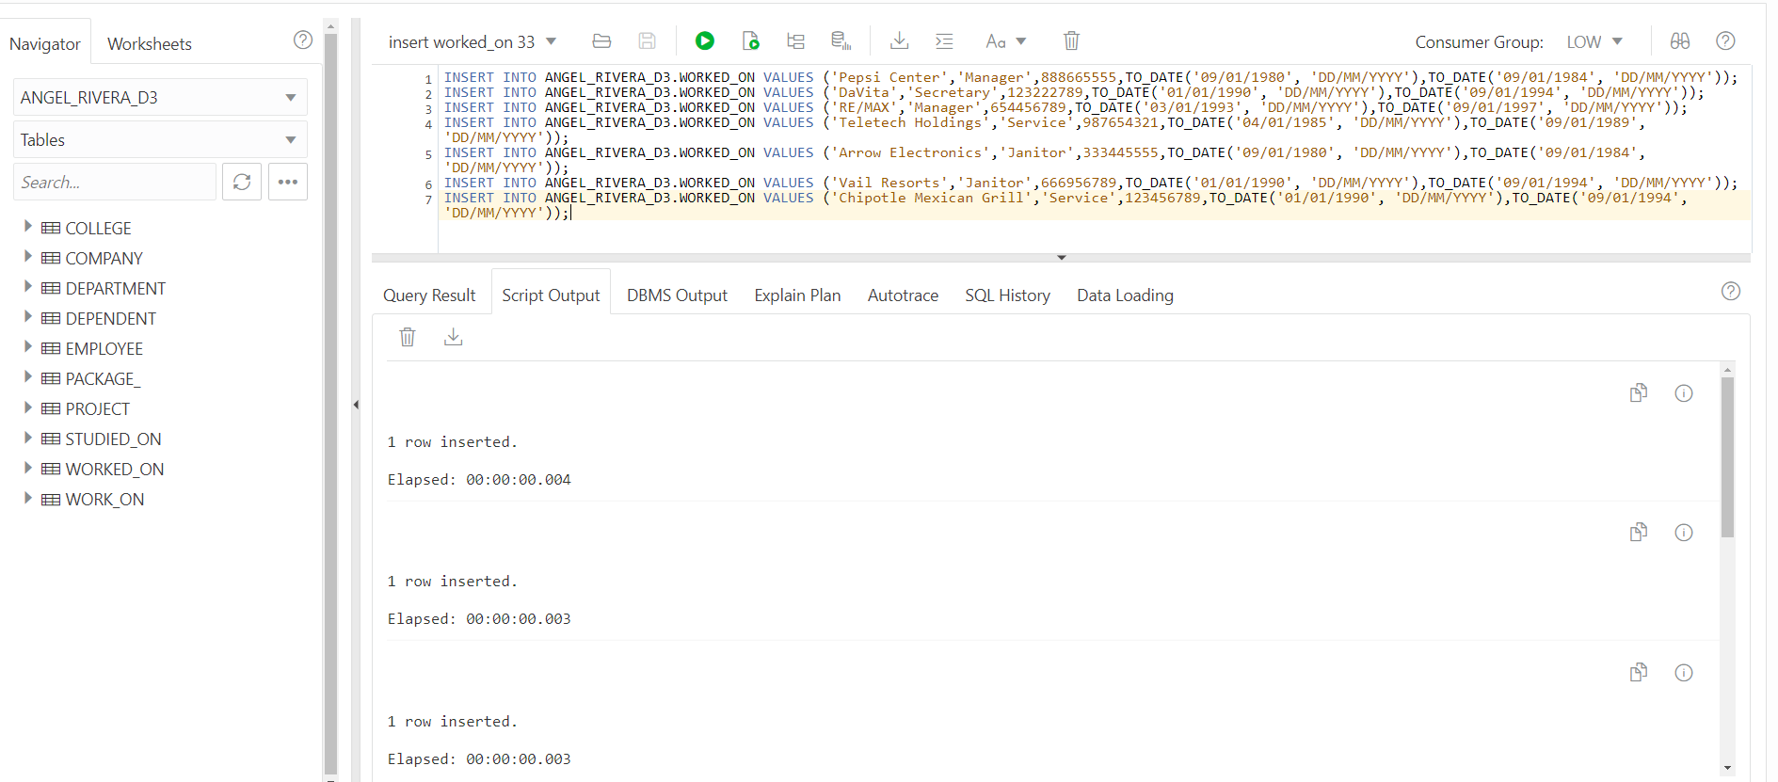

Figure 24.9

INSERT INTO ANGEL_RIVERA_D3.WORKED_ON VALUES ('Pepsi Center','Manager',888665555,TO_DATE('09/01/1980', 'DD/MM/YYYY'),TO_DATE('09/01/1984', 'DD/MM/YYYY'));

INSERT INTO ANGEL_RIVERA_D3.WORKED_ON VALUES ('DaVita','Secretary',123222789,TO_DATE('01/01/1990', 'DD/MM/YYYY'),TO_DATE('09/01/1994', 'DD/MM/YYYY'));

INSERT INTO ANGEL_RIVERA_D3.WORKED_ON VALUES ('RE/MAX','Manager',654456789,TO_DATE('03/01/1993', 'DD/MM/YYYY'),TO_DATE('09/01/1997', 'DD/MM/YYYY'));

INSERT INTO ANGEL_RIVERA_D3.WORKED_ON VALUES ('Teletech Holdings','Service',987654321,TO_DATE('04/01/1985', 'DD/MM/YYYY'),TO_DATE('09/01/1989', 'DD/MM/YYYY'));

INSERT INTO ANGEL_RIVERA_D3.WORKED_ON VALUES ('Arrow Electronics','Janitor',333445555,TO_DATE('09/01/1980', 'DD/MM/YYYY'),TO_DATE('09/01/1984', 'DD/MM/YYYY'));

INSERT INTO ANGEL_RIVERA_D3.WORKED_ON VALUES ('Vail Resorts','Janitor',666956789,TO_DATE('01/01/1990', 'DD/MM/YYYY'),TO_DATE('09/01/1994', 'DD/MM/YYYY'));

INSERT INTO ANGEL_RIVERA_D3.WORKED_ON VALUES ('Chipotle Mexican Grill','Service',123456789,TO_DATE('01/01/1990', 'DD/MM/YYYY'),TO_DATE('09/01/1994', 'DD/MM/YYYY'));

Appendix 10

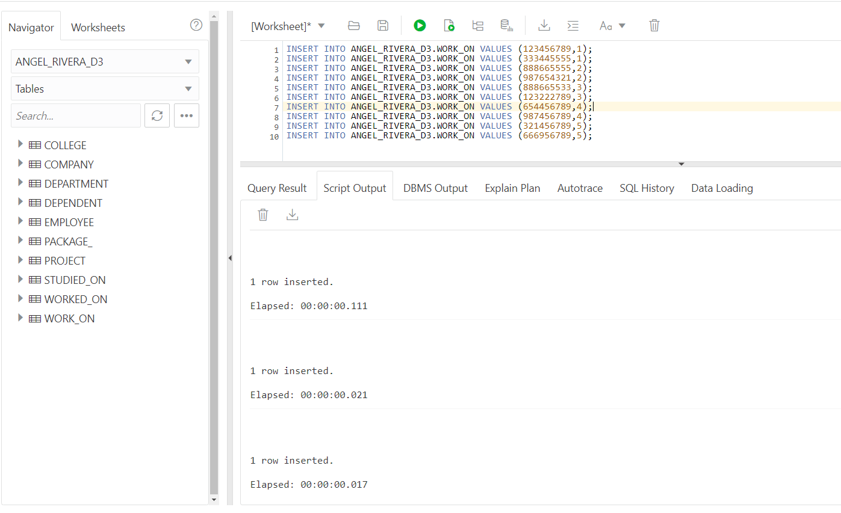

Figure 25.10

INSERT INTO ANGEL_RIVERA_D3.WORK_ON VALUES (123456789,1);

INSERT INTO ANGEL_RIVERA_D3.WORK_ON VALUES (333445555,1);

INSERT INTO ANGEL_RIVERA_D3.WORK_ON VALUES (888665555,2);

INSERT INTO ANGEL_RIVERA_D3.WORK_ON VALUES (987654321,2);

INSERT INTO ANGEL_RIVERA_D3.WORK_ON VALUES (888665533,3);

INSERT INTO ANGEL_RIVERA_D3.WORK_ON VALUES (123222789,3);

INSERT INTO ANGEL_RIVERA_D3.WORK_ON VALUES (654456789,4);

INSERT INTO ANGEL_RIVERA_D3.WORK_ON VALUES (987456789,4);

INSERT INTO ANGEL_RIVERA_D3.WORK_ON VALUES (321456789,5);

INSERT INTO ANGEL_RIVERA_D3.WORK_ON VALUES (666956789,5);

Appendix 11

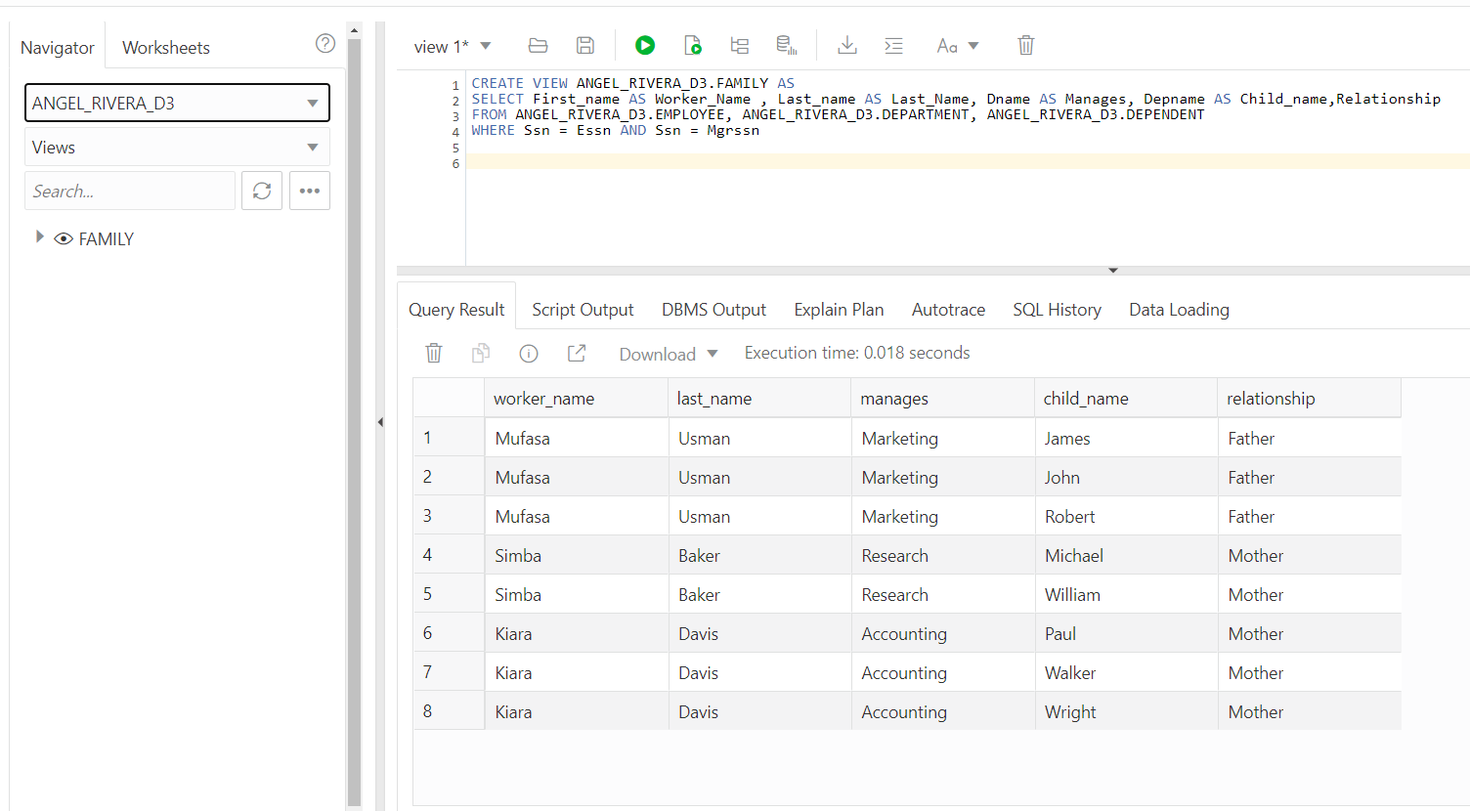

Figure 26.11

CREATE VIEW ANGEL_RIVERA_D3.FAMILY AS

SELECT First_name AS Worker_Name , Last_name AS Last_Name, Dname AS Manages, Depname AS Child_name,Relationship

FROM ANGEL_RIVERA_D3.EMPLOYEE, ANGEL_RIVERA_D3.DEPARTMENT, ANGEL_RIVERA_D3.DEPENDENT

WHERE Ssn = Essn AND Ssn = Mgrssn

Appendix 12

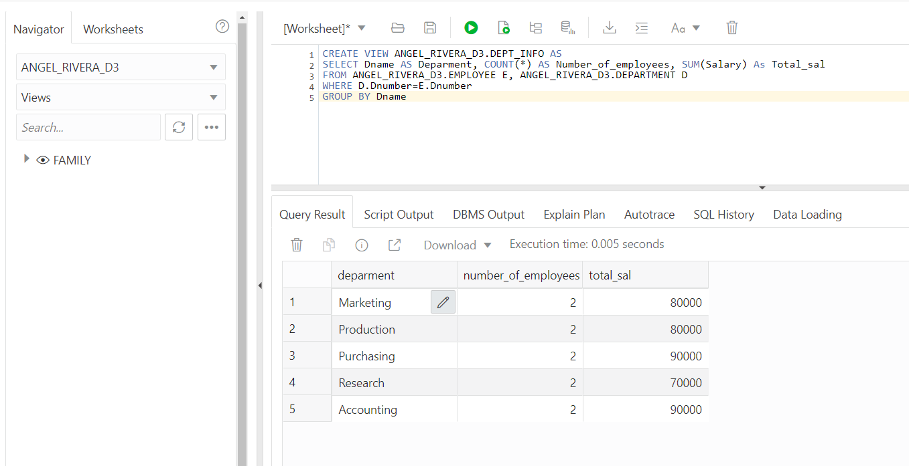

Figure 27.12

CREATE VIEW ANGEL_RIVERA_D3.DEPT_INFO AS

SELECT Dname AS Department, COUNT(*) AS Number_of_employees, SUM(Salary) As Total_sal

FROM ANGEL_RIVERA_D3.EMPLOYEE E, ANGEL_RIVERA_D3.DEPARTMENT D

WHERE D.Dnumber=E.Dnumber

GROUP BY Dname

Appendix 13

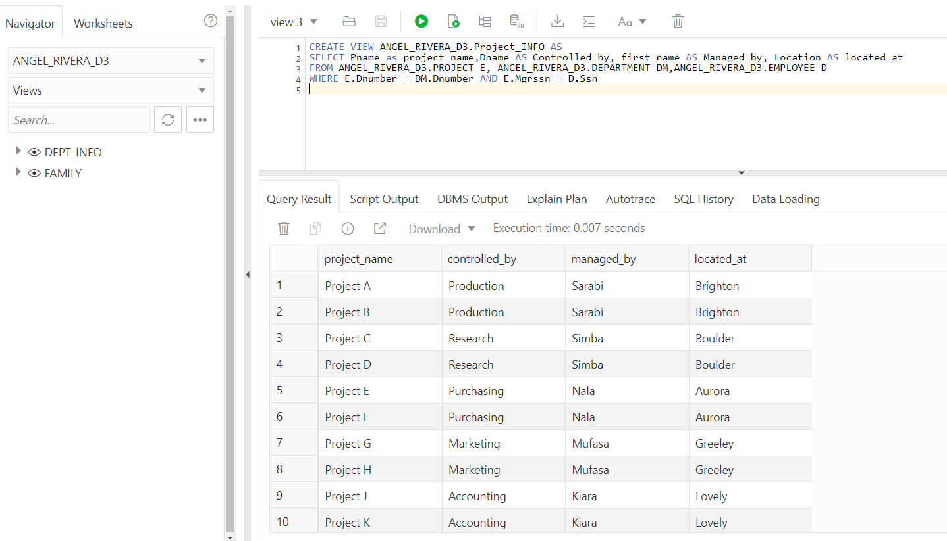

Figure 28.13

CREATE VIEW ANGEL_RIVERA_D3.Project_INFO AS

SELECT Pname as project_name, Dname AS Controlled_by, first_name AS Managed_by, Location AS located_at

FROM ANGEL_RIVERA_D3.PROJECT E, ANGEL_RIVERA_D3.DEPARTMENT DM,ANGEL_RIVERA_D3.EMPLOYEE D

WHERE E.Dnumber = DM.Dnumber AND E.Mgrssn = D.Ssn

Appendix 14

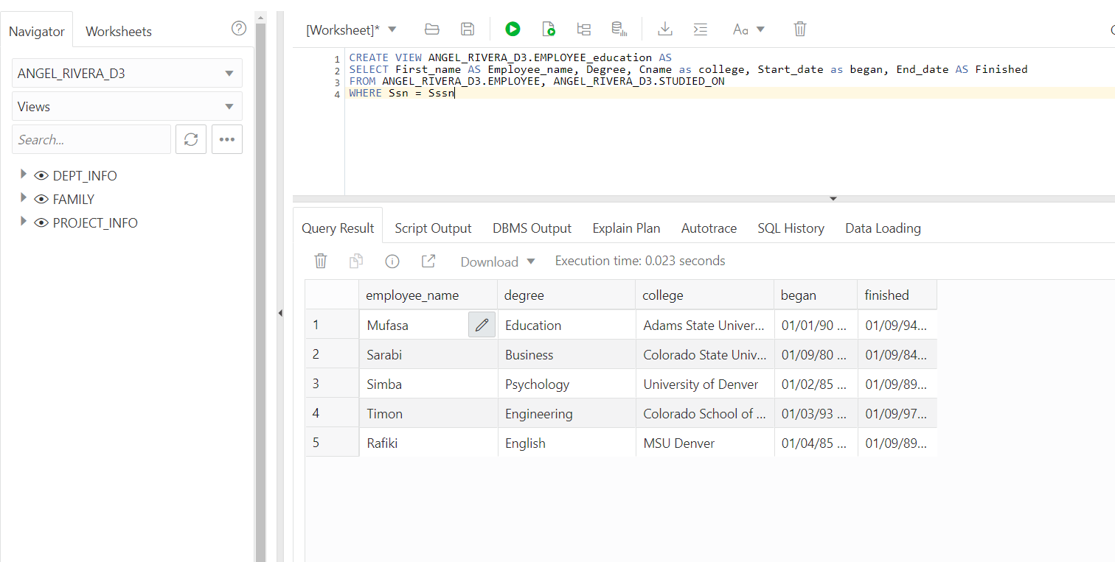

Figure 29.14

CREATE VIEW ANGEL_RIVERA_D3.EMPLOYEE_education AS

SELECT First_name AS Employee_name, Degree, Cname as college, Start_date as began, End_date AS Finished

FROM ANGEL_RIVERA_D3.EMPLOYEE, ANGEL_RIVERA_D3.STUDIED_ON

WHERE Ssn = SSsn

Appendix 15

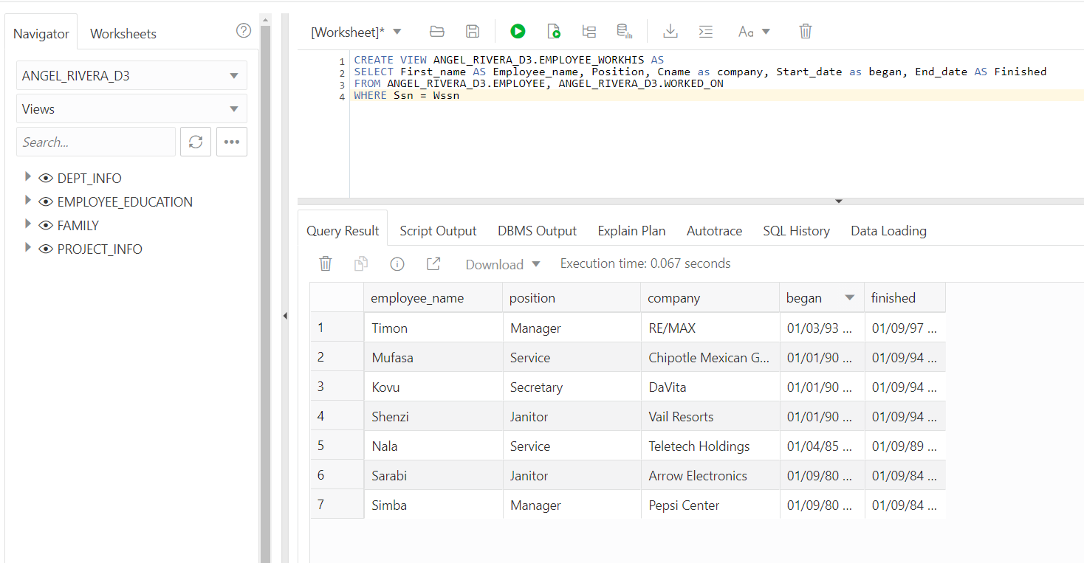

Figure 30.15

CREATE VIEW ANGEL_RIVERA_D3.EMPLOYEE_WORKHIS AS

SELECT First_name AS Employee_name, Position, Cname as company, Start_date as began, End_date AS Finished

FROM ANGEL_RIVERA_D3.EMPLOYEE, ANGEL_RIVERA_D3.WORKED_ON

WHERE Ssn = WSsn

Appendix 16

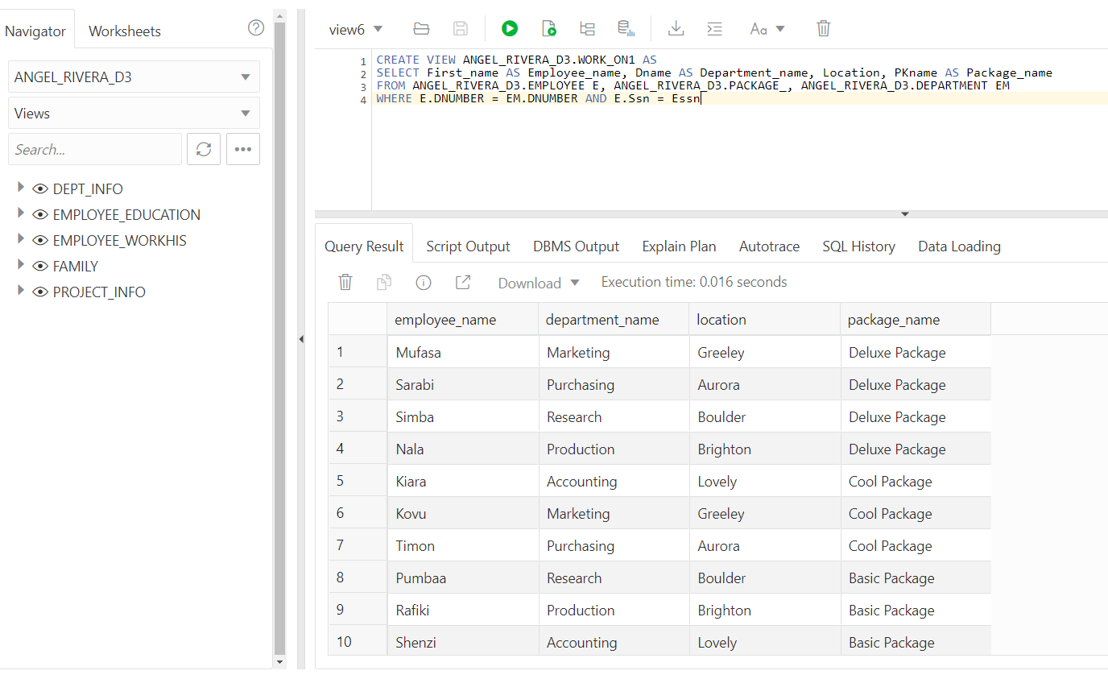

Figure 31.16

CREATE VIEW ANGEL_RIVERA_D3.WORK_ON1 AS

SELECT First_name AS Employee_name, Dname AS Department_name, Location, PKname AS Package_level

FROM ANGEL_RIVERA_D3.EMPLOYEE E, ANGEL_RIVERA_D3.PACKAGE_, ANGEL_RIVERA_D3.DEPARTMENT EM

WHERE E.DNUMBER = EM.DNUMBER AND E.Ssn = Essn

# Appendixes Hadoop/Warehouse

1. College
2. Company
3. Department
4. Dependent
5. Employee
6. Package
7. Project
8. Studied_on
9. Worked_on
10. Work_on
11. Salary_Employee
12. Deparment_employee
13. SalaryClassification_Salary
14. Salary_Department_employee
15. Salary_gender_employee
16. Salary_gender_department
17. BSalary_package
18. Joint-Query
19. BSalaryVsSalary
20. Employee_package_salary
21. BSalary_gender_employee
22. Department_salary_employee
23. FactFinal_College
24. FactFinal_Company
25. FactFinal_Department
26. FactFinal_Dependent
27. FactFinal_Employee
28. FactFinal_Package
29. FactFinal_Project
30. FactFinal_Studied_on
31. FactFinal_Work_on
32. FactFinal_Worked_on

Appendix A1

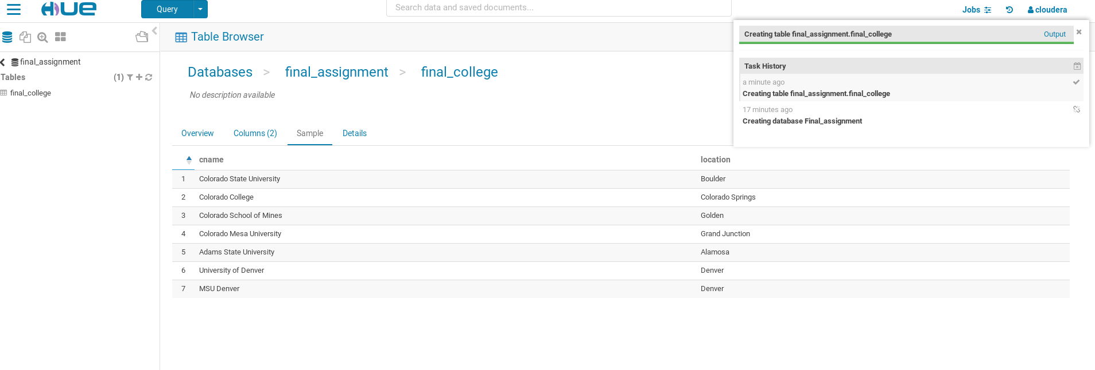

Figure A1.1

Appendix B2

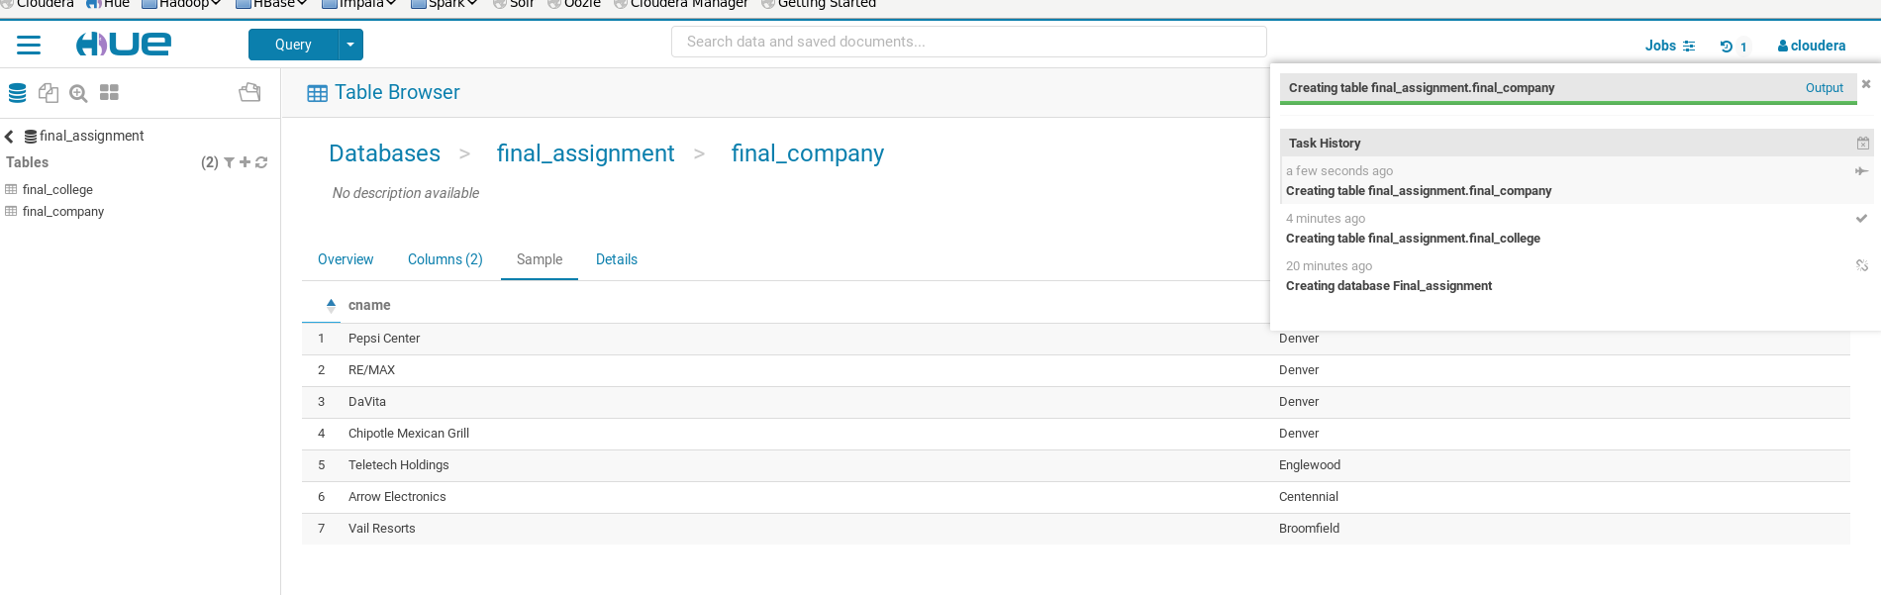

Figure B2.2

Appendix C3

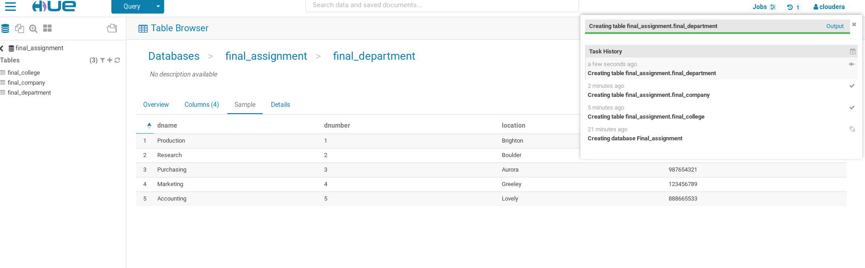

Figure C3.3

Appendix D4

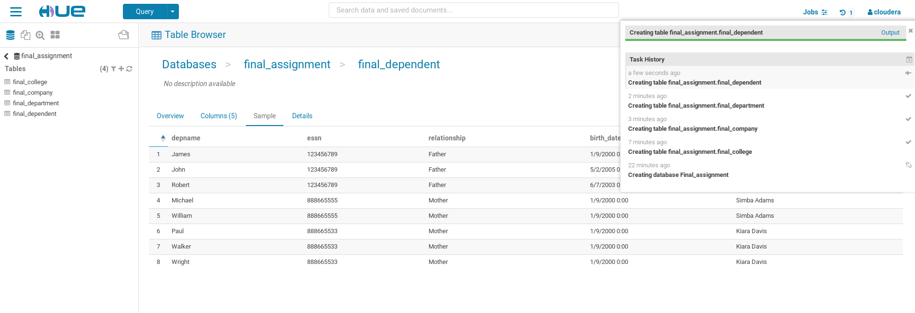

Figure D4.4

Appendix E5

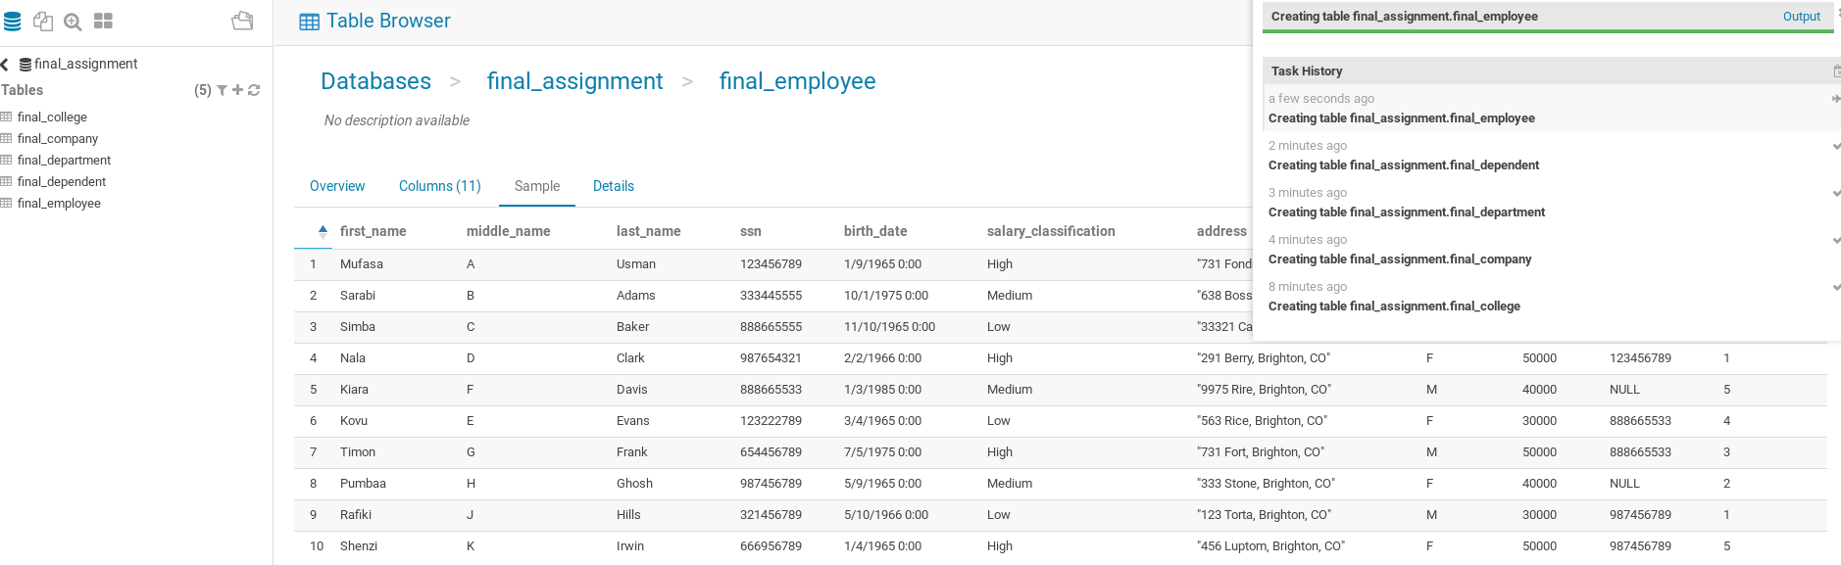

Figure E5.5

Appendix F6

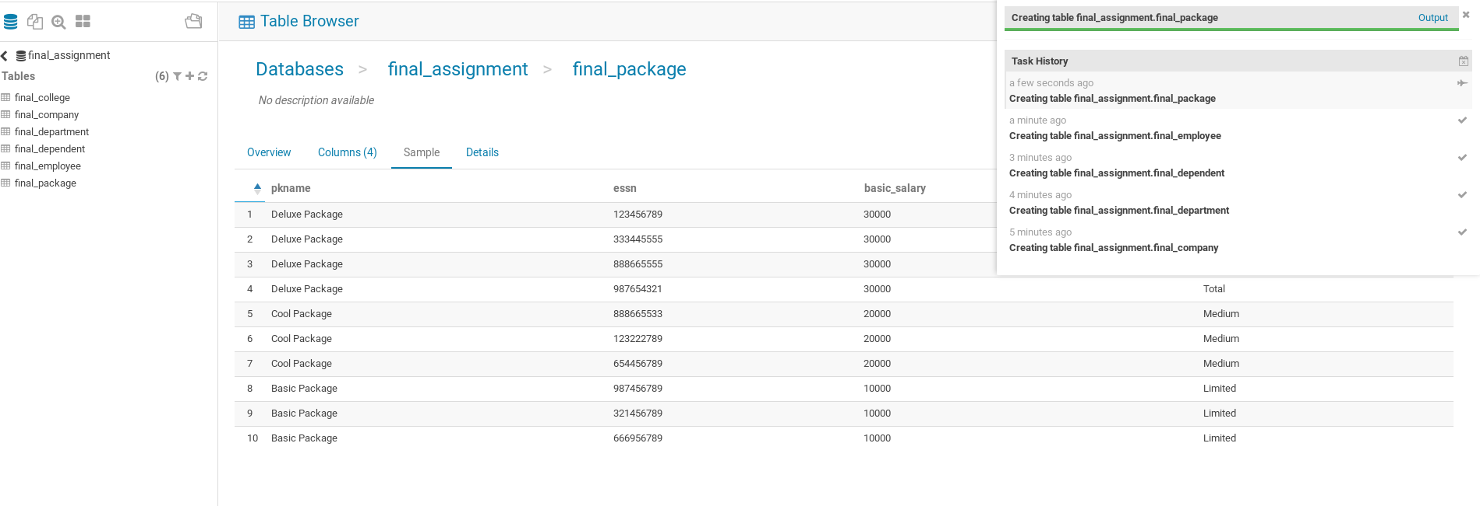

Figure F6.6

Appendix G7

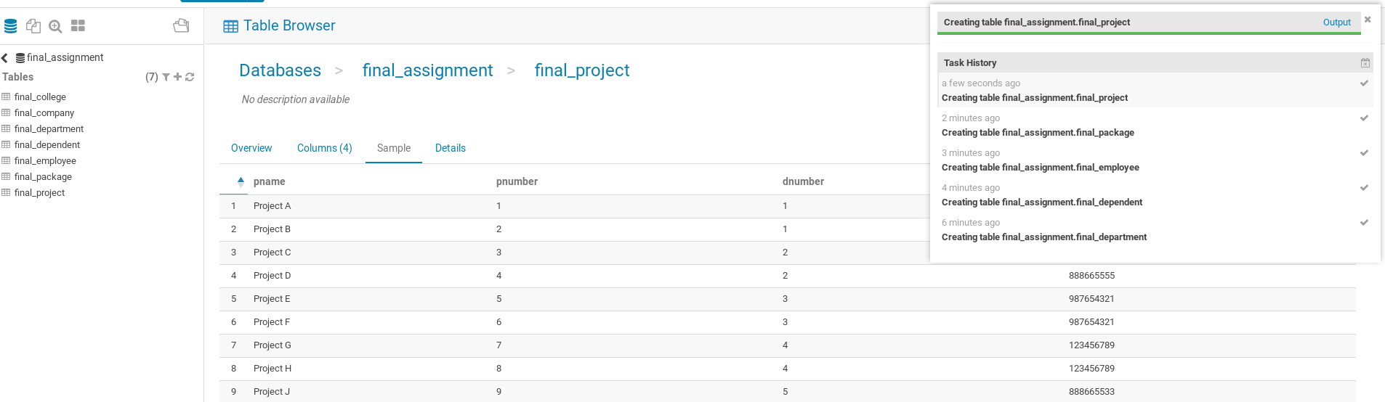

Figure G7.7

Appendix H8

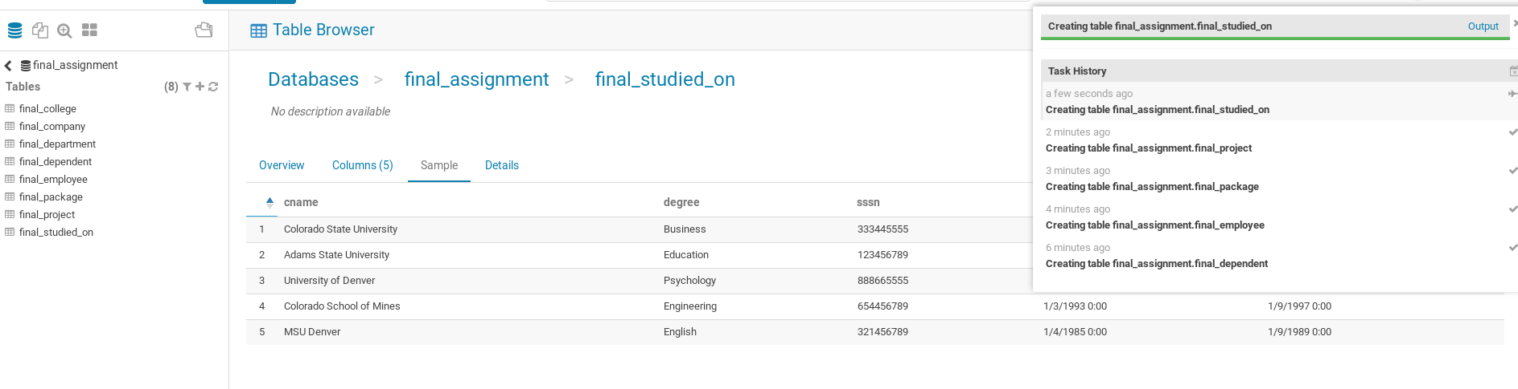

Figure H8.8

Appendix I9

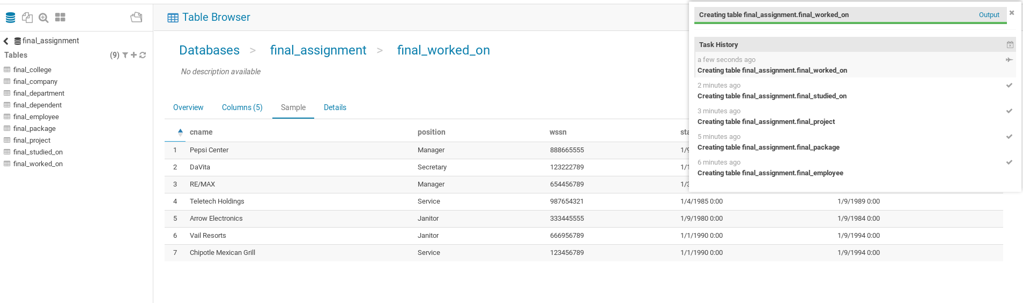

Figure I9.9

Appendix J10

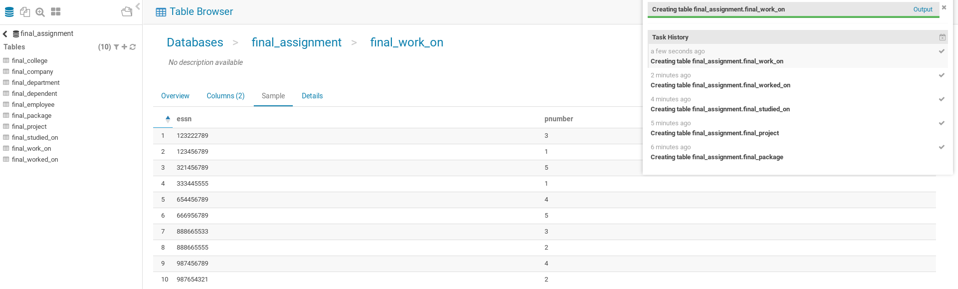

Figure J10.10

Appendix K11

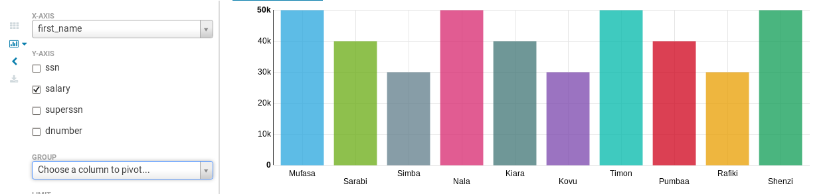

Figure K11.11

Appendix L12

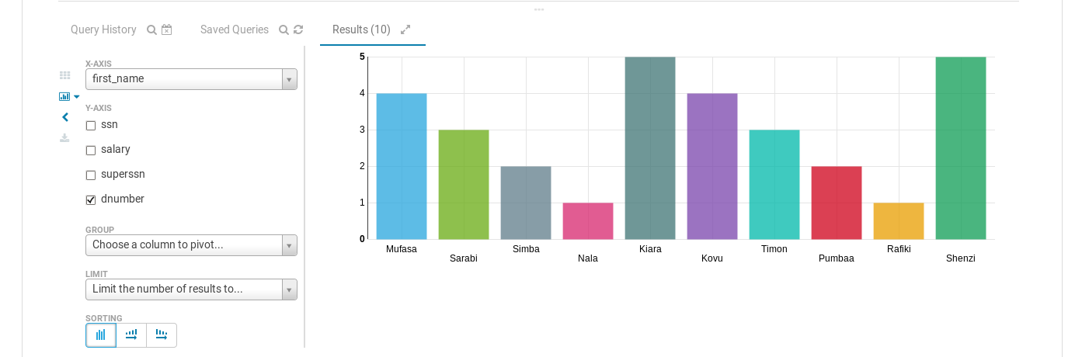

Figure L12.12

Appendix M13

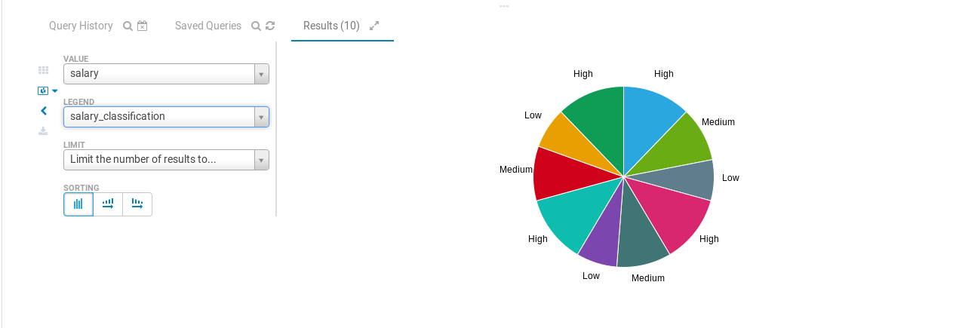

Figure M13.13

Appendix N14

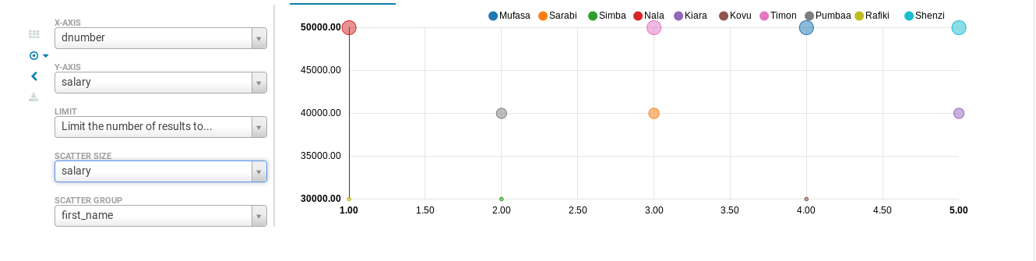

Figure N14.14

Appendix O15

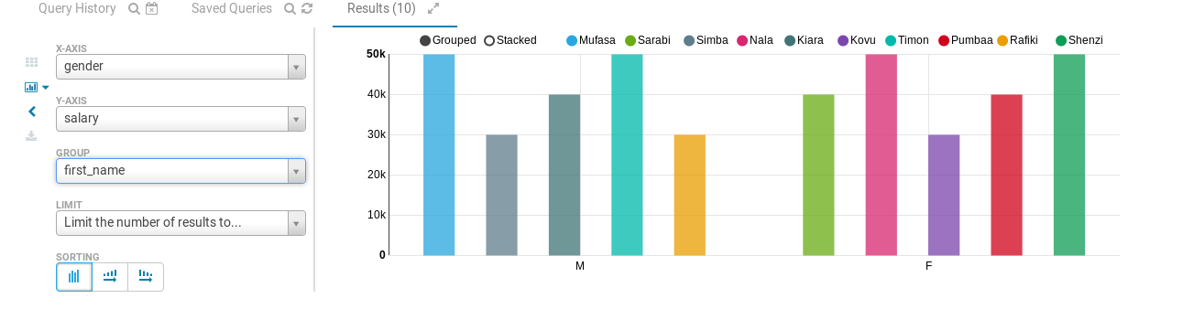

Figure O15.15

Appendix P16

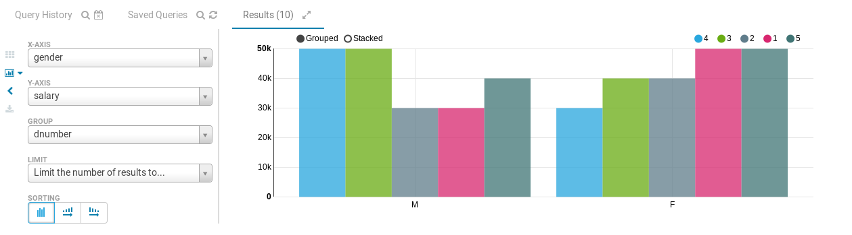

Figure P16.16

Appendix Q17

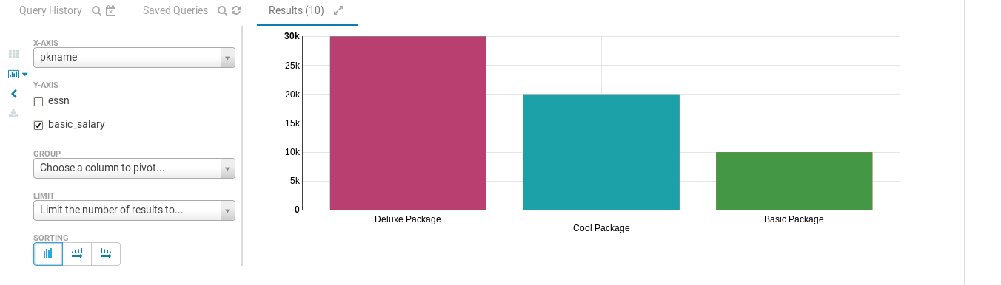

Figure Q17.17

Appendix R18

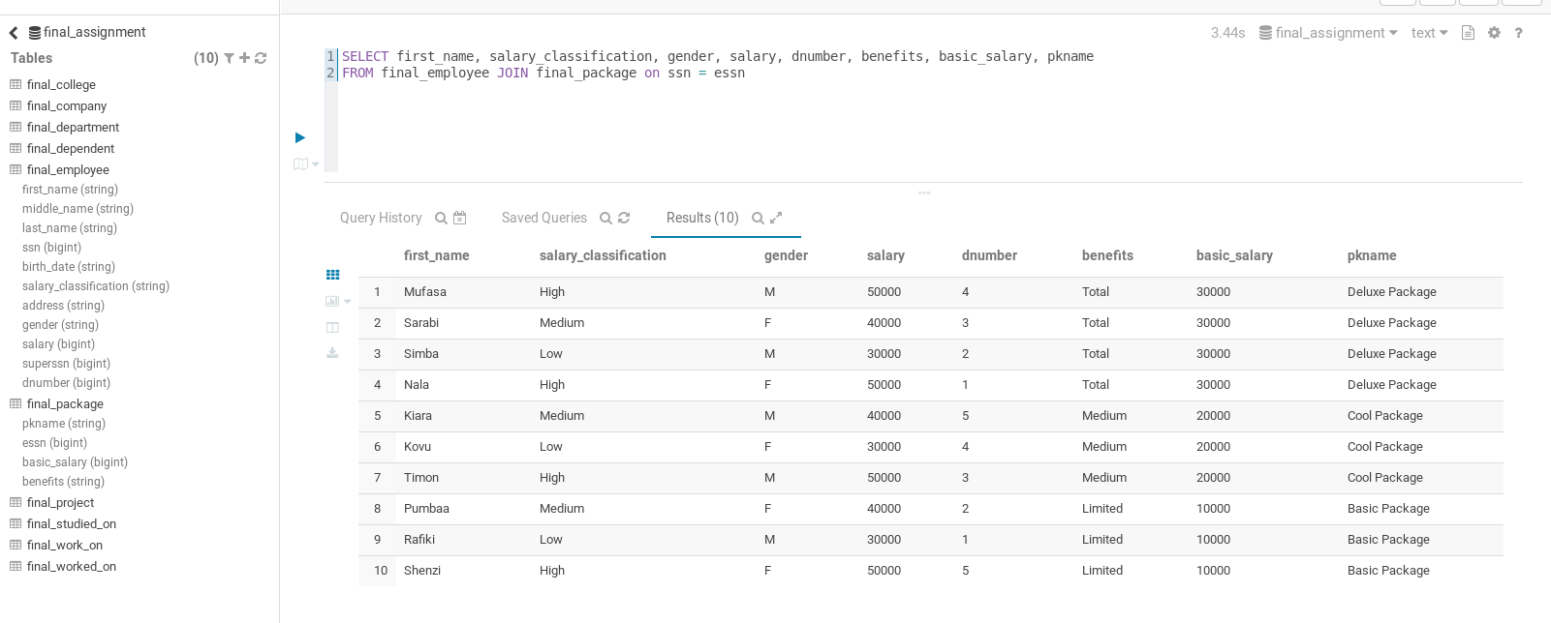

Figure R18.18

Appendix S19

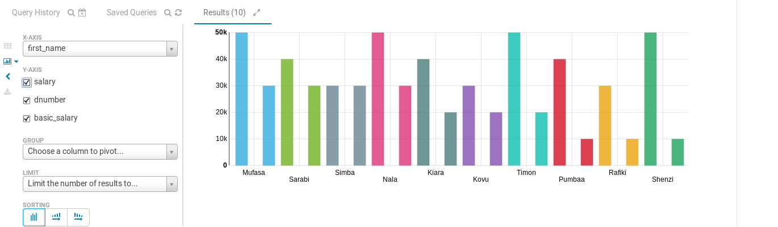

Figure S19.19

Appendix T20

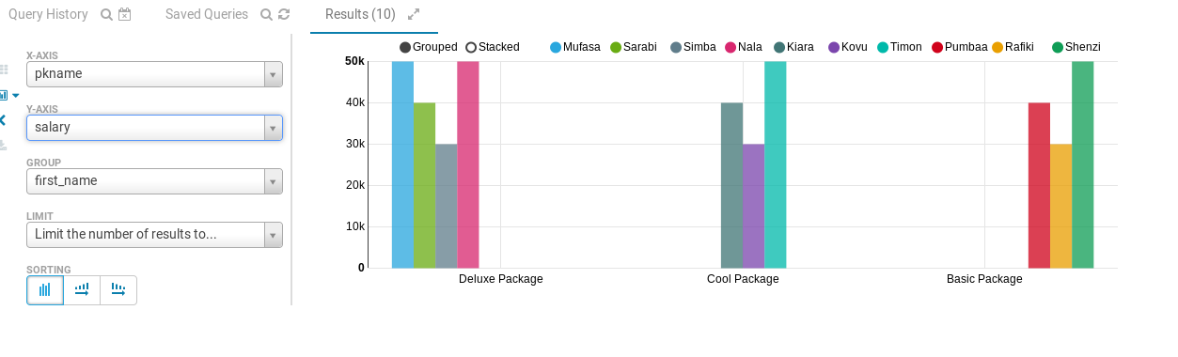

Figure T20.20

Appendix U21

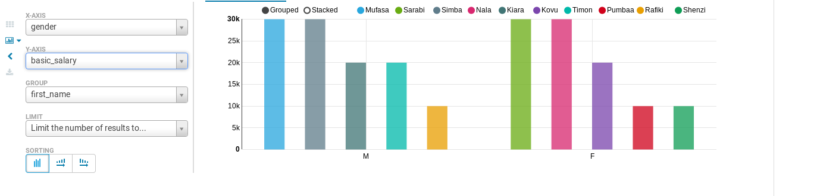

Figure U21.21

Appendix V22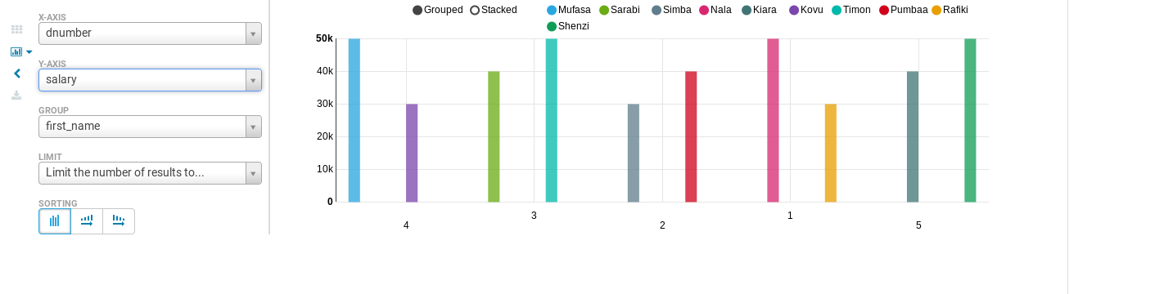

Figure V22.22

Appendix X23

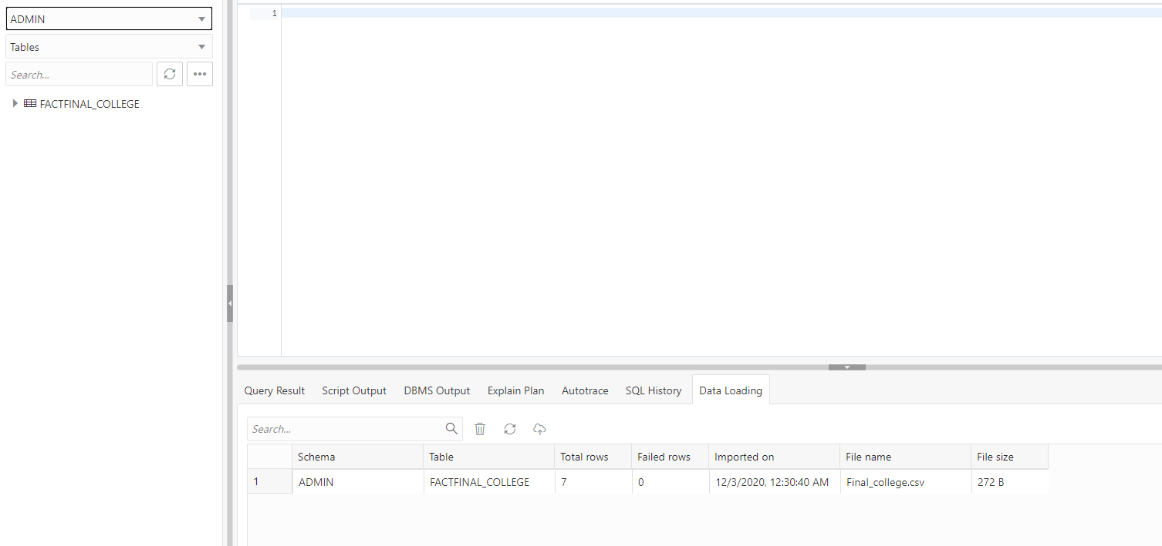

Figure X23.23

Appendix Y24

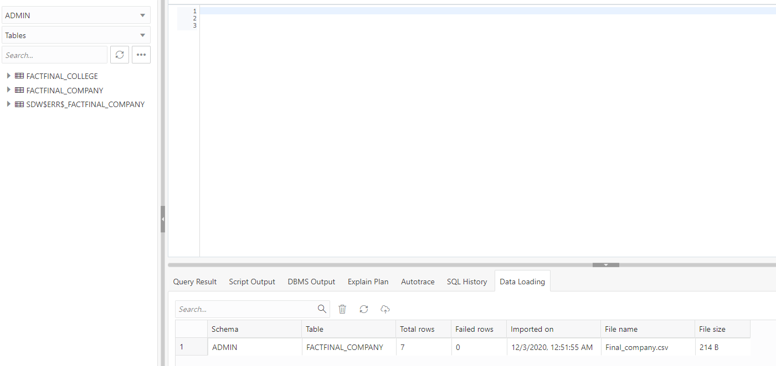

Figure Y24.24

Appendix Z25

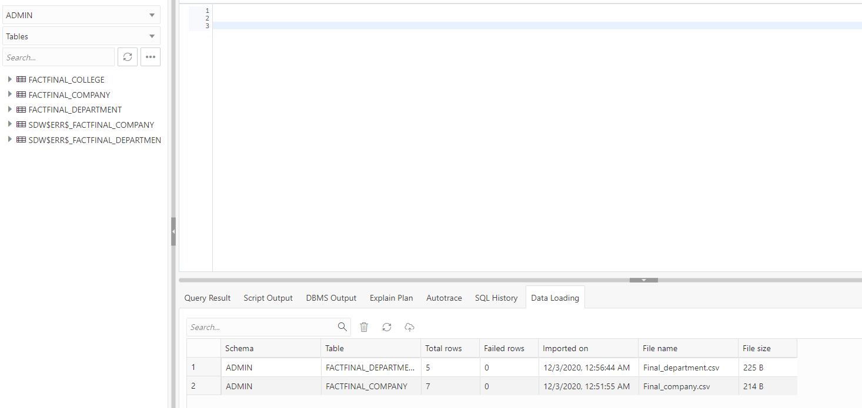

Figure Z25.25

Appendix AA26

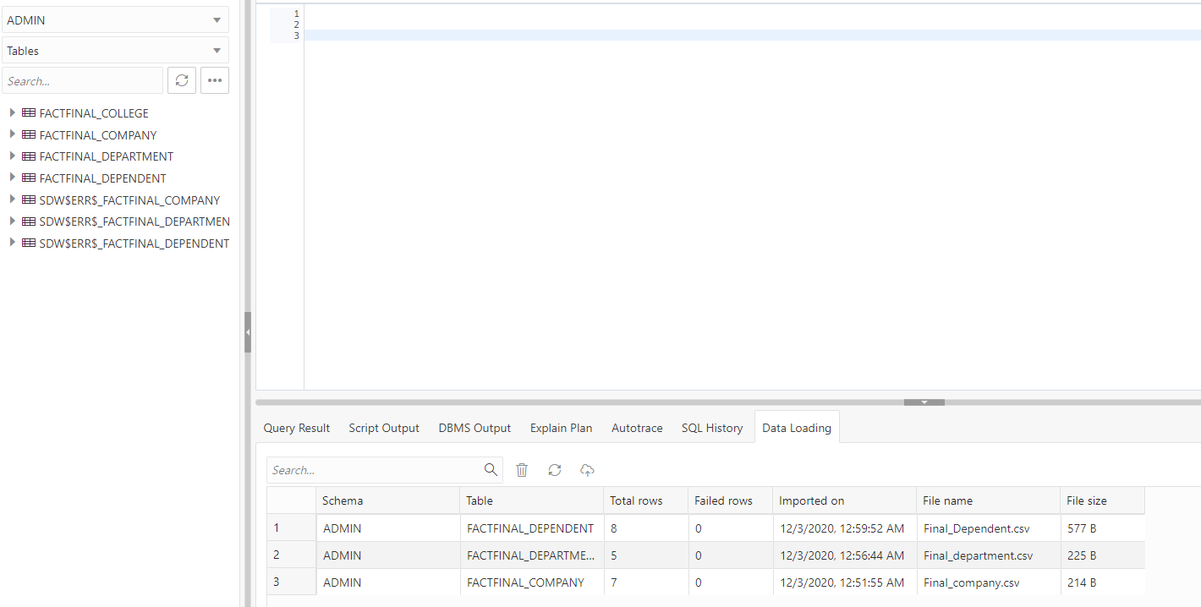

Figure AA26.26

Appendix AB27

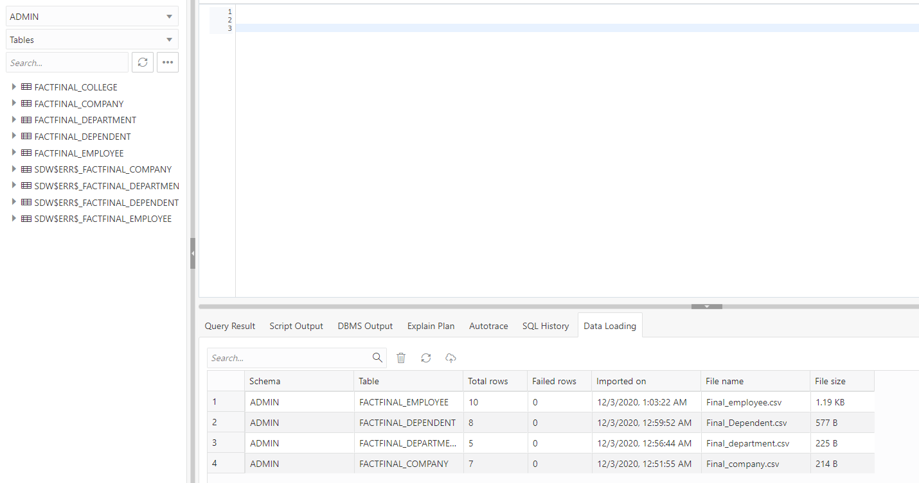

Figure AB27.27

Appendix AC28

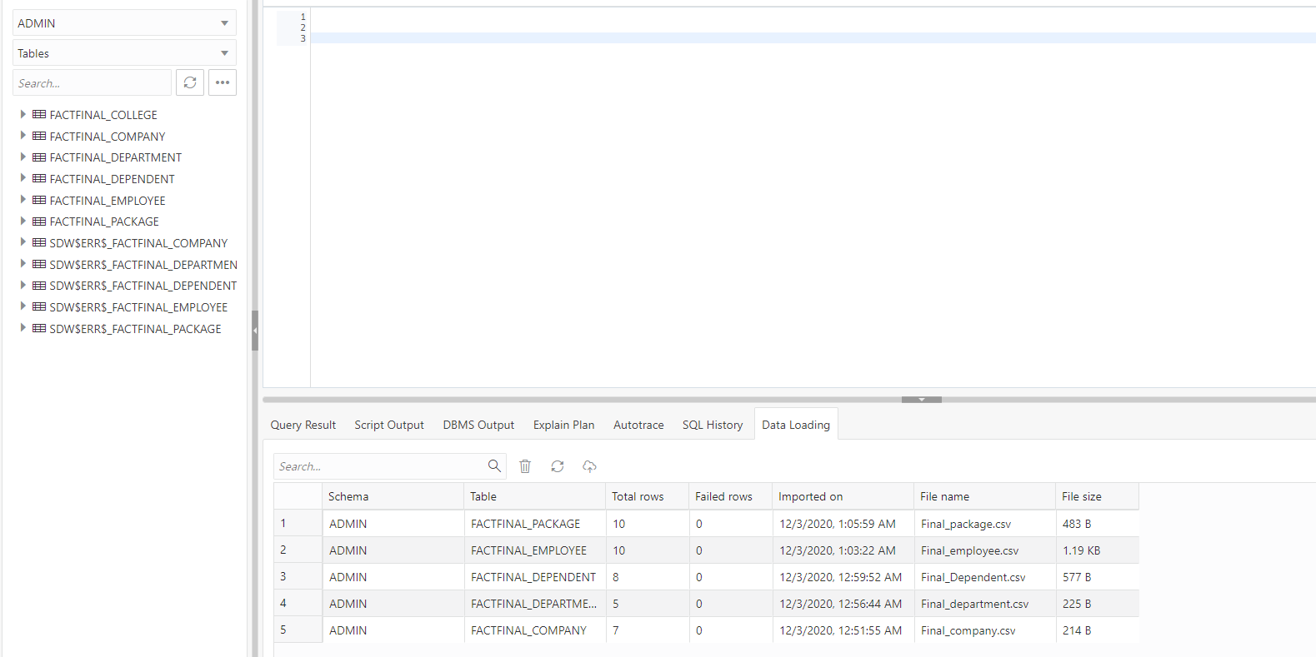

Figure AC28.28

Appendix AD29

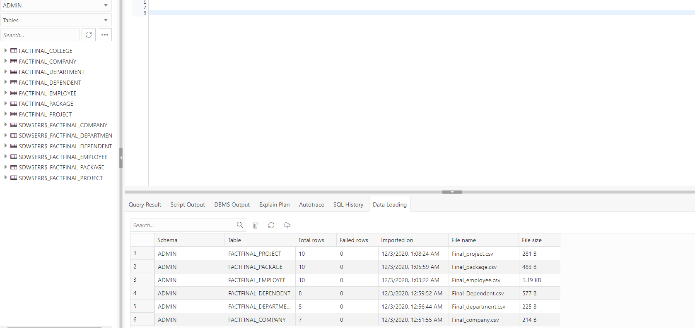

Figure AD29.29

Appendix AE30

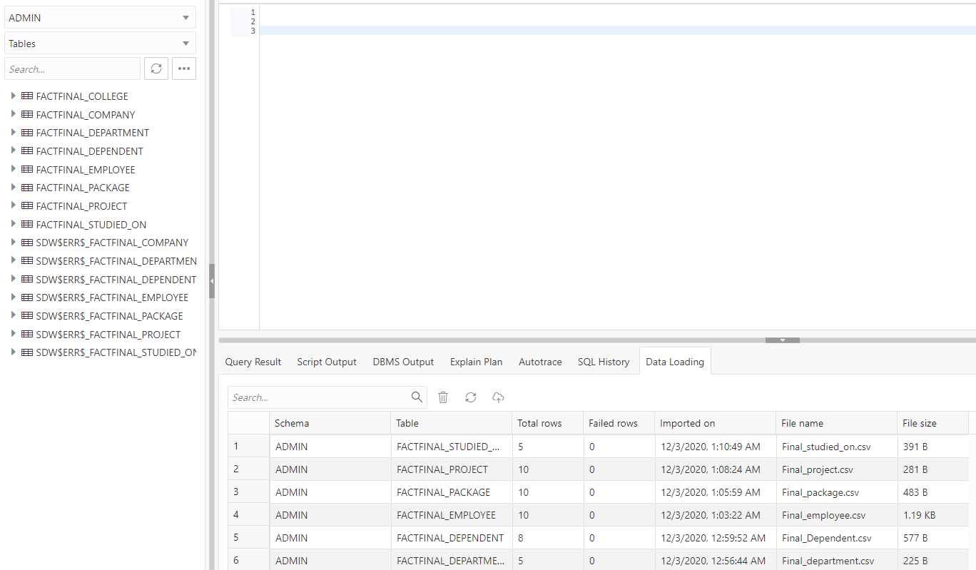

Figure AE30.30

Appendix AF31

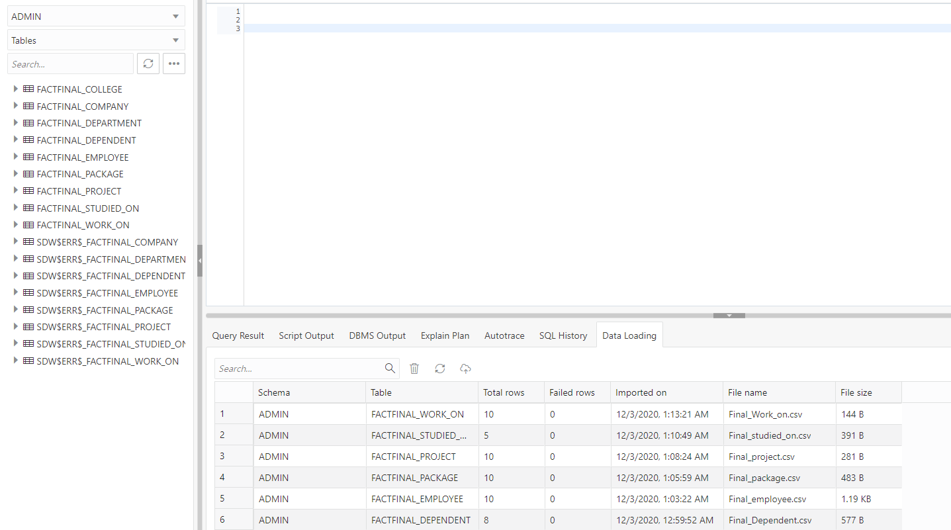

Figure AF31.31

Appendix AG32

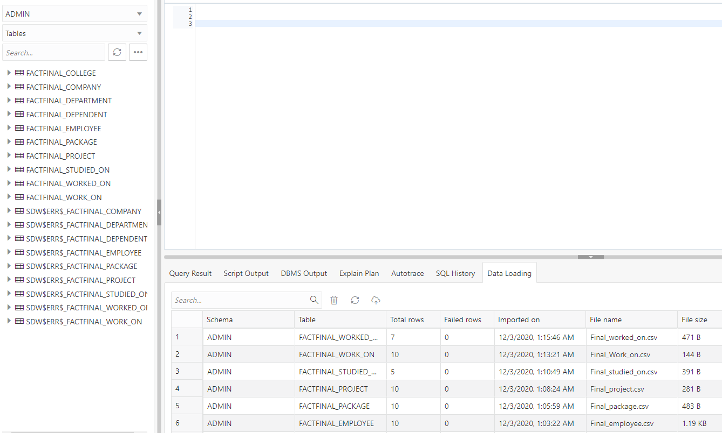

Figure AG32.32

## References

Elmasri, Ramez, and Shamkant B. Navathe. *Fundamentals of Database Systems*. 7th ed., Pearson, 2017.

Foster, Elvis C, and Shripad Godbole. Database Systems: A Pragmatic Approach. 2014. <https://link-springer-com.unco.idm.oclc.org/chapter/10.1007/978-1-4842-1191-5_30>

Sudha, Ram, and Vijay, Khatri. *A comprehensive framework for modeling set-based business rules during conceptual database design.* Volume: 30 Issue: 2, Information systems (Oxford), 2005, Page: 89-118. <https://www-sciencedirect-com.unco.idm.oclc.org/science/article/pii/S0306437903001078>